First Page Template for Project-Related Documents

**CARE: Social Death Awareness Initiative**

PROJECT LOG



## Table of Contents

Introduction 3

1. Understanding the Social Isolation Schema 4

1.1. Foundations of Schema Theory: Understanding Early Maladaptive Patterns 5

1.2. Social Isolation Schema 10

1.3. Recognising symptoms of social isolation 12

1.4. Ostracism 14

1.5. Distinguishing Social Isolation from Social Death 15

2. Understanding Social Deprivation Pathway Development 19

2.1. The Importance of Attachment in Human Development 20

2.2 Exploring the Social Deprivation Pathways 21

2.3. Cycle of Social Isolation Schema 23

2.4. Life experiences: providing examples of social deprivation pathways 26

2.5. Managing Social Isolation in Workplaces 27

3. Identifying Knowledge, Skills, Competencies, and Experiences for Recognising Social Isolation 29

3.1. Knowledge: Understanding Beyond Social Isolation and Death 29

3.2. Skills: Applying Awareness in Real-Life Situations 32

3.3. Competences: The Ability to Take Effective Action 35

3.4. Experiences: Gaining and Creating Inclusive Environments 38

3.5 Addressing Social Isolation Through Structured Interventions 39

4. Social Connectedness recommendations 43

4.1. Understanding the Social Isolation Schema 43

4.2. Understanding Social Deprivation Pathway Development 43

4.3. Identifying Knowledge, Skills, Competencies, and Experiences for Recognising Social Isolation 43

CONCLUSIONS 45

REFERENCES 46

## Introduction

In today's world, social isolation is increasingly seen as a serious public health issue affecting individual well-being and community strength. The "Social Isolation Schema: Pattern Explication" is a crucial guide that helps understand the complex reasons behind social isolation, from how people think to the broader social factors that contribute to it. At its core, social isolation is more than being physically apart from others; it involves profound emotional and mental experiences that can significantly impact a person's mental health and ability to connect with others.

This guide begins by explaining the basic ideas of schema theory, showing how mental frameworks shape views, actions, and relationships. It draws upon the work of influential psychologists like Aaron Beck and Jeffrey Young, focusing on early maladaptive schemas—especially the Social Isolation Schema—as lenses through which individuals see their social world. By learning about these schemas' origins, traits, and effects, readers will gain valuable insights into their thoughts and behaviours, helping them create healthier connections with themselves and others.

Chapter 1 lays the groundwork by discussing the development and effects of the Social Isolation Schema. It highlights how early experiences, especially those related to feeling disconnected or deprived, shape a person's sense of belonging. Understanding these schemas is vital because they often appear in adult relationships, leading to patterns of emotional withdrawal and feelings of being alone. The guide stresses that addressing these ongoing patterns is crucial for individual healing and improving mental health in community settings.

Chapters 2 and 3 expand on this foundation by exploring how social deprivation develops and identifying essential skills that professionals and individuals need to recognize and respond to signs of social isolation. This part focuses on how early relationships and societal factors contribute to feelings of exclusion. It reveals how emotional needs, personal situations, and cultural influences work together to foster or hinder social connections.

Finally, Chapter 4 presents practical recommendations and resources through 12 branching scenarios designed to reinforce the knowledge gained throughout the guide. These scenarios act as training tools, allowing readers to apply the concepts learned in real-life situations. They provide chances for reflection and practice, helping individuals understand how to build social connections in various settings, like adult education institutions and workplaces.

Through this in-depth look at the Social Isolation Schema, the guide aims to provide the knowledge, skills, and practical tools needed to build meaningful connections, reduce feelings of isolation, and create more inclusive communities. By understanding and addressing the roots of social isolation, individuals can overcome harmful patterns and lead more fulfilling lives connected to the world around them.

## Understanding the Social Isolation Schema

This chapter explores the Social Isolation Schema, focusing on its formation, characteristics, and effects on thoughts, perceptions, and behaviours. Schemas are cognitive frameworks that significantly guide our actions and interactions. Understanding the Social Isolation Schema is crucial as it affects relationships and mental health. By recognising and addressing this schema, individuals can enhance self-awareness, change behaviours, and improve relationships, leading to healthier and more fulfilling lives. This knowledge empowers individuals to identify and modify detrimental patterns.

### 1.1. Foundations of Schema Theory: Understanding Early Maladaptive Patterns

According to Beck's cognitive perspective, mental concepts such as assumptions, schemas, memories, beliefs, goals, expectations, plans, tasks and cognitive biases influence people's behavioural and emotional responses to the social environment (Beck, 1967; Ahmadpanah et al., 2017). Schemas are considered cognitive structures that encode and respond to environmental stimuli; they can be both positive and negative, as well as early and later schemas. (Sfeir et al., 2025). Every non-adaptive schema has a corresponding adaptive schema (see Elliott's polarity theory, Elliott & Lassen, 1997). Following Erikson's (1950) psychosocial stages, successful resolution of each stage results in an adaptive schema, whereas failure to resolve the situation results in a maladaptive schema. (Young et al., 2003).

As Sfeir points out, building on Beck's cognitive schema model, Young extended the model to study early maladaptive schemas that lead to distorted thoughts about the world, self and others. (Young,1999; Sfeir et al., 2025). Schema theory emphasises the relationship between cognitive and emotional processes and behaviour change. In this theory, early maladaptive schemas are a central concept originating from adverse childhood events. (Sfeir et al., 2025). Early maladaptive schemas can be understood as filters that determine how we anticipate, order and interpret our environment, and they emerge as adaptations to negative childhood experiences. (Bär et. al., 2023). Maladaptive schemas arise from basic emotional needs not being met in childhood.

*In other words, Sfeir explains that Young built on Beck's cognitive schema theory to examine early negative thinking patterns called maladaptive schemas, which affect how we think about ourselves, others, and the world. Schema theory focuses on how our thoughts and feelings are connected to changes in our behaviour. These early maladaptive schemas often result from difficult experiences in childhood.These schemas can be considered filters that shape how we see and understand our surroundings. They usually develop as a way to cope with adverse childhood experiences. Maladaptive schemas often form because basic emotional needs weren't met when we were young.*

Young and colleagues postulated five basic human emotional needs that are universal:

1. Secure attachments to others (includes safety, stability, nurturance, and acceptance);

2. Autonomy, competence, and sense of identity;

3. Freedom to express valid needs and emotions;

4. Spontaneity and play;

5. Realistic limits and self-control.

Everyone experiences these needs, although some individuals feel them more intensely than others. A psychologically balanced person can healthily fulfil these fundamental emotional needs. The interplay between a child's natural temperament and their early surroundings often leads to the frustration, rather than satisfaction, of these essential needs. Additional factors beyond the early environment also significantly influence the development of schemas. The emotional temperament of the child is particularly crucial. As most parents quickly notice, each child possesses a unique and distinct “character” or temperament from birth. Some children are more irritable, others are more reserved, and some exhibit more aggression. A substantial amount of research supports the significance of the biological foundations of personality. (Young et al., 2003).

*In other words, Young and colleagues identified five essential emotional needs that all humans share:*

*1.Forming safe and secure connections with others;*

*2.Having independence, capability, and a clear sense of self;*

*3.Being free to express genuine needs and emotions;*

*4.Enjoying spontaneity and play;*

*5.Understanding realistic boundaries and self-control.*

*While everyone has these needs, some people feel them more strongly. A mentally healthy person can meet these needs in a balanced way. Often, a child's inborn temperament and early environment can lead to unmet needs. Besides early experiences, other factors also play a big role in shaping how these needs are met. A child's natural personality is vital; as many parents observe, every child has a unique temperament from birth. Some children may be more easily upset, others more shy, and some might be more aggressive. Research supports that biological aspects strongly influence personality.*

Young's (1990, 1999) hypothesised that some of these patterns, which are mainly the result of toxic childhood experiences, could underlie personality disorders, milder character problems and many chronic disorders. Early maladaptive schemas are self-defeating emotional and cognitive patterns that begin early in our development and recur throughout life. Young believes that maladaptive behaviour develops in response to schemas. Thus, behaviour is determined by schemas but is not part of schemas. (Young et al., 2003). Early maladaptive schemas include cognitions, memories, emotions and patterns, and these schemas contribute to maladaptive behaviour. Suppose someone was abandoned, abused or rejected as a child. In that case, their schemas will be activated in adulthood after being triggered by events that may seem similar to the traumatic experiences they had in childhood. When one of these circuits is activated, they experience strong negative emotions such as sadness, shame, fear or anger. (Young et al., 2003; Sfeir et al., 2025).

However, as Young points out, not all patterns are based on childhood trauma or maltreatment. An individual can develop an addiction/incompetence schema without experiencing any childhood trauma and be fully protected in childhood. Although not all schemas originate from trauma, all are destructive, and most are caused by harmful experiences that are repeated regularly. The impact of all these related toxic experiences is cumulative, and together, they lead to the emergence of a complete schema. The dysfunctional nature of schemas is usually most apparent later in life, when the individual continues to perpetuate their schemas in interactions with other people, even though their perceptions are no longer accurate. Early maladaptive schemas and the maladaptive ways in which the individual learns to cope with them are often the basis for chronic symptoms such as anxiety, depression, substance abuse and psychosomatic disorders. Schemas are dimensional, meaning they have different levels of severity and prevalence—the more severe the schema, the greater the number of situations that trigger it. (Young et al., 2003).

*In other words, Young suggests that harmful patterns from difficult childhood experiences can lead to personality disorders and other issues later in life. These patterns, called early maladaptive schemas, shape how people think and behave, often causing negative emotions when triggered by similar situations in adulthood. Not all schemas come from trauma, but many are damaging and can contribute to problems like anxiety and depression as individuals repeat these patterns in their interactions with others.*

**Early maladaptive schemas**

Early maladaptive schemas have been shown in research to play an important role in addiction, obsessive/compulsive disorders, depression and anxiety. (Ahmadpanah et al., 2017; Griffiths, 2014; Kwak & Lee, 2015; Platts et al., 2005).

Young and colleagues' 'schema therapy', which treats individuals with profound and chronic psychological disorders previously considered difficult to treat, comprises 18 early maladaptive schemas divided into five schema domains.   
 **Domain I,** **"Disconnection and Rejection"**, comprises unmet needs such as safety and empathy. A typical family background is detached, cold, rejecting, aloof, lonely, explosive, unpredictable or abusive. Individuals with this schema from this area cannot securely attach to others, believing that they will not be able to receive stability, love or security. Adults with schemas from this domain tend to move rapidly from one self-destructive relationship to another or avoid close relationships altogether.

1. **Abandonment/Instability** schema, manifested by expecting others to abandon you.

2. **Mistrust/Abuse** schema manifested by expecting others to harm.

3. **Emotional Deprivation** schema is manifested in the expectation that others will not be emotionally supportive.

4. **Defectiveness/Shame** schema is manifested by the belief that you are inferior and useless.

5. **Social Isolation/Alienation** schema is expressed in feeling different and isolated from others.

*In other words,* ***Domain I, "Disconnection and Rejection,"*** *includes unmet needs like safety and understanding. People from families that are distant, cold, or abusive often develop these schemas. They struggle to form secure attachments, believing they won't find stability or love. As adults, they may jump from one harmful relationship to another or avoid intimacy entirely.*

*1.* ***Abandonment/Instability schema:*** *Always expecting people to leave you.*

*2.* ***Mistrust/Abuse schema:*** *Always expecting others to hurt you.*

*3.* ***Emotional Deprivation schema:*** *Believing others won't support you emotionally.*

*4.* ***Defectiveness/Shame schema:*** *Feeling inferior and worthless.*

*5.* ***Social Isolation/Alienation schema:*** *Feeling different and alone.*

**Domain II,** "**Impaired Autonomy and Performance**" disorder, is characterised by the inability to separate oneself from parental figures and to form who they are an independent personality. Individuals with this domain have either had overprotective parents or, on the contrary, parents who have failed to care for their needs. Typical family origins include wallowing, undermining of the child's self-esteem, overprotection and failure to strengthen the child to be able to function permanently outside the family.

6. **Dependency/Incompetence** scheme. The belief that one is incapable or incompetent to look after oneself.

7. **Vulnerability to Harm or Disease.** Exaggerated fear that something terrible will happen at any moment and that the person will not be able to prevent it.

8. **Enmeshment/Undeveloped Self** Schema. Excessive emotional involvement and closeness with significant others at the expense of full individualisation or normal social development.

9. **Failure** schema. The belief is that failure is inevitable and that one is entirely useless.

*In other words,* ***Domain II, "Impaired Autonomy and Performance,"*** *is about struggling to become independent and form a sense of self separate from parents. People in this domain might have experienced either overprotective parenting or neglect. These families can undermine a child's confidence, be overly protective, or fail to prepare the child to function outside the home.*

*6.* ***Dependency/Incompetence schema:*** *Believing you can't care for yourself.*

*7.* ***Vulnerability to Harm or Disease:*** *Constant fear that something terrible will happen and you can't stop it.*

*8.* ***Enmeshment/Undeveloped Self-schema:*** *Being too emotionally close to others, preventing personal growth.*

*9.* ***Failure schema:*** *Believing you're bound to fail and feel worthless.*

**Domain III** is " **Impaired Limits**", where patterns include an inability to cooperate in social settings, make commitments, or follow the rules. Individuals are unable to control their impulses. A typical family background is characterised by permissiveness, excessive tolerance, lack of direction or a sense of superiority, rather than appropriate confrontation, discipline and limits on taking responsibility, cooperation and installation.

10. **Entitlement/Grandiosity** scheme. The belief that a person deserves special treatment.

11. **Insufficient Self-Control/Self-Discipline**. Difficulty in delaying gratification for the sake of a long-term goal. Overemphasis on avoiding discomfort.

*In other words****, Domain III, "Impaired Limits,"*** *involves struggles with behaving correctly in social situations, making commitments, and following rules. People in this domain often can't control their impulses. They may have grown up in too lenient families, lacked guidance, or made them feel overly special instead of being taught responsibility and cooperation.*

*10.* ***Entitlement/Grandiosity schema:*** *Believing you deserve special treatment.*

*11.* ***Insufficient Self-Control/Self-Discipline:*** *Difficulty waiting for long-term benefits and wanting to avoid discomfort.*

**Domain IV,** "**Other-Directedness,**" involves prioritising other people's needs over your own to gain their approval/love. The typical family origin is based on conditional acceptance: children have to suppress essential aspects of their being to gain love, attention and appreciation.

12. **Subjugation** scheme. Suppression of one's own needs/emotions, one feels controlled by others.

13. **Self-sacrifice** scheme. Attention is focused on meeting the needs of others at the expense of self.

14. **Approval/recognition-seeking schema**. Excessive focus on receiving approval from others instead of developing self-reliance.

*In other words,* ***Domain IV, "Other-Directedness,"*** *is about putting others' needs before your own to earn their approval or love. Typically, this comes from families where children felt they had to hide parts of themselves to be loved and valued.*

*12.* ***Subjugation schema:*** *Ignoring your needs and emotions, feeling dominated by others.*

*13.* ***Self-sacrifice schema:*** *Prioritizing others' needs over your own.*

*14.* ***Approval/recognition-seeking schema:*** *Seeking others' approval instead of trusting yourself.*

**Domain V** is **"Overvigilance and Inhibition**", which includes inhibiting and suppressing one's emotions and impulses. Rigid norms and values characterise it. These patterns reflect the unmet emotional needs of childhood. The typical origin is a grim, repressed, and strict childhood in which self-control and self-denial predominated over spontaneity and pleasure.

15. **Negativity/Pessimism** scheme. Extreme and constant focus on all that is harmful.

16**. Emotional Inhibition** scheme. The belief is that it is necessary to inhibit emotions to avoid being judged by others, feeling shame or losing control of one's impulses.

17. **Unrelenting Standards/Hypercriticalness** scheme. The belief is that achieving extremely high standards is necessary to avoid criticism.

18. **Punitiveness** scheme. The belief is that mistakes should be severely punished. This includes a tendency to be angry, intolerant, punitive, and impatient with people (including oneself). (Young et al., 2003; Young et al., 2006; Sfeir et al., 2025; Bär et. al., 2023; Ahmadpanah et. al., 2017).

*In other words,* ***Domain V, "Overvigilance and Inhibition,"*** *is about holding back and controlling emotions and impulses, guided by strict rules and values. This usually stems from a gloomy and strict upbringing where restraint was valued over fun and enjoyment.*

*15.* ***Negativity/Pessimism schema:*** *Focusing too much on potential dangers and negative outcomes.*

*16.* ***Emotional Inhibition schema:*** *Believing emotions must be controlled to avoid judgment, shame, or loss of control.*

*17.* ***Unrelenting Standards/Hypercriticalness schema:*** *You must meet very high standards to avoid criticism.*

*18.* ***Punitiveness schema:*** *Believing mistakes should be harshly punished, leading to anger and impatience with yourself and others.*

All humans strive for connection, understanding, and growth, driven by a deep desire to be recognised. When these needs are hindered by deprivation, neglect, trauma, or loss, our longings intensify. We need to heal and evolve into our best selves, which can lead to a sense of vitality and renewed energy. Schema Therapy incorporates neurophysiology, highlighting that positive, safe relationships promote emotional regulation. The brain's ability to change, combined with a secure therapeutic relationship, offers the promise of fulfilment, transforming feelings of depression, anxiety, and loneliness while guiding us toward greater peace.

### 1.2. Social Isolation Schema

Toxic childhood experiences are the primary origin of early maladaptive schemas. The schemas that develop earlier and are the strongest usually originate in the family. To a large extent, the dynamics of the child's family are the dynamics of the child's entire early world. When individuals are in adult situations where early maladaptive schemas are activated, they usually experience drama from their childhood, usually with their parents. Other influences, such as peers, school, community groups and the surrounding culture, become increasingly important as the child matures and can also trigger the development of schemas. However, schemas developed later are usually not as standard. For example, social isolation is an example of a schema that generally emerges later in childhood or adolescence and may not reflect family dynamics. According to Young, the social isolation/exclusion schema is the feeling of being different or not fitting into the wider social world outside the family. Typically, individuals with this early maladaptive schema do not feel part of any group or community. (Young et al., 2003). In general, according to Young's early maladaptive schema psychotherapy framework, social isolation, as mentioned above, is grouped with other schemas based on one category or domain of unmet emotional needs - Disconnection and Rejection.

The Bay Area Cognitive Behavioural Therapy Center Schema explains how to identify and address social isolation. Persons haunted by social isolation feel separated and alienated from their environment throughout their lives. This is not just a temporary state of loneliness; it is a very painful pattern that permeates their existence, affecting how they perceive and interact with the world. The person consistently tells them that they do not belong, are fundamentally different, and will never really belong to any social group.

This scheme, which operates in the shadows, often goes unnoticed even by the person. People with this schema may appear sociable, even extroverts, well-liked, and have a wide circle of friends, but internally feel isolated, struggling with a sense of loneliness that social activities seem unable to alleviate. This painful pattern is reinforced as they strive for connection, creating a paradox in which trying to belong to a group only deepens their sense of isolation.

A closer look at the origins of social isolation reveals that its seeds are often planted early in life, but can emerge at different stages and are shaped by a complex interaction between personal experiences and societal structures.

* Interactions within the family environment, where a deficiency in belonging can alienate individuals from crucial social support.
* Early life experiences, especially those related to parents who feel disappointment or inadequacy, can embed a profound sense of not measuring up, paving the way for increased social exclusion.
* The teenage years and cultural influences further mould the social environment by deepening feelings of loneliness or providing a sense of community and belonging.

**The impact of childhood**. Feelings of social isolation can begin to take hold in childhood, as negative experiences such as bullying, exclusion, and mistreatment from classmates reinforce the pattern of isolation. In the absence of peer support, children can develop a chronic sense of isolation that can persist into adulthood. This early peer interaction is crucial as it influences immediate social experiences and affects the persistence of social isolation patterns in later life. Family relationships with siblings are also clearly meaningful. A supportive family can foster a sense of belonging and acceptance, while a lack of recognition from a cold and toxic family can create alienation.

**Adolescence.** Adolescence is a time of identity and independence exploration, which can be turbulent. Inappropriate social support reinforces psychosocial development at this stage, while social relationships act as a support against alienation. As we move into adulthood, isolation problems develop as the need for belonging and acceptance remains. The impact of these needs is visible in personal well-being and professional or academic success.

**Cultural and societal factors.** The impact of social isolation is closely linked to cultural and societal factors. Laws and policies against marginalisation and discrimination can strengthen social ties and reduce feelings of isolation. The World Health Organisation is working to tackle this problem, focusing on vulnerable groups such as older people. Research shows that women and people with lower levels of education or chronic illness suffer more from the cognitive effects of isolation, pointing to gender and educational differences in these issues.

The interaction between cognitive performance and social isolation is a stark reminder of the pervasive consequences of feelings of disconnection. Those with better cognitive performance are associated with more stable levels of social isolation over time. Older adults, in particular, are prone to loneliness, a key indicator of social isolation, which underlines the importance of societal support and inclusion for this demographic.

*In other words, the social isolation schema often originates from negative childhood experiences and can cause individuals to feel disconnected from others throughout their lives. Although they may seem sociable on the outside, those with this schema often feel like they do not belong to any group, leading to deep feelings of loneliness. This sense of isolation can be shaped by family dynamics, peer interactions, and societal influences, and is further complicated by factors like gender and education, highlighting the need for support and community to combat feelings of disconnection.*

### 1.3. Recognising symptoms of social isolation

These symptoms can be emotional, behavioural or cognitive, and understanding them is the first step in combating the effects of the scheme. Individuals struggling with social isolation may outwardly appear to be doing fine, but inwardly, they are struggling with feelings of loneliness and disconnection that contradict their social behaviour. Their efforts to connect with others can paradoxically lead to a widening gap between them and the sense of belonging they seek. Even though a wide social circle may surround them, they may still feel that others do not understand them. Some signs of social isolation include:

* Experiencing loneliness and detachment even when surrounded by others;
* Finding it difficult to create profound and significant relationships with people;
* Feeling misinterpreted or not genuinely recognised by those around you;
* Maintaining an active social circle yet still grappling with feelings of isolation;
* Acknowledging these indicators is crucial for effectively tackling social isolation.

**The signs that someone is silently struggling with a social isolation scheme**

**Emotional indicators.** Emotional indicators, often the most substantial signs of social isolation, are characterised by feelings of loneliness, sadness and sometimes even hopelessness. Individuals with this pattern may feel lonely and isolated, preferring loneliness to the eventual exhaustion of relationships. Loneliness is not just being alone; the perception of a gap between desired and actual interpersonal relationships leads to emotional emptiness, which can manifest as sadness, emptiness or hopelessness. These feelings are often accompanied by hypersensitivity to the reactions of others and a tendency to self-criticism, which can develop into anger or depression. Feelings of loneliness correlate with a perceived lack of social support, and these emotions can be reinforced by anxiety and self-consciousness, creating a vicious circle that is difficult to break.

Recognising these emotional indicators is essential to understanding and addressing social isolation. The internal emotional landscape of an individual with a pattern of social isolation can be turbulent, influenced by a complex interplay of factors that can exacerbate feelings of disconnection and inhibit their ability to form meaningful relationships.

**Behavioural signs.** Insight into the presence of a social isolation pattern can be gained from behavioural cues. These behaviours often include:

* Avoiding social events;
* Preferring solitude;
* Not participating in organised group activities;
* Rarely engaging in social interaction;
* Showing disinterest in community participation;
* Changing routines to avoid social engagement;
* Masking avoidance with efforts to appear attractive or likeable, driven by fear of rejection;
* Loss of interest in previously enjoyed activities;
* Poor self-care;
* These behaviours reflect the emotional distress caused by social isolation.

In addition, the emotional toll of prolonged isolation can lead to aggression, lethargy, energy depletion in social settings, and sleep disturbances.

For older adults, smaller social networks or fewer interactions underline the physical isolation accompanying social isolation. Avoiding social interaction out of loneliness can have serious consequences, leading to depression and suicidal thoughts.

**Cognitive patterns.** Cognitive patterns associated with the social isolation schema are essential in maintaining feelings of alienation. Individuals may experience:

* Pretending to fit in, masking their true selves from the belief that their authentic self is "unusual" or facing rejection, which reinforces a strong inner critic;
* Preoccupation with being seen as a burden;
* A tendency to distrust others for no tangible reason;
* These patterns contribute to perpetuating feelings of social isolation and alienation.

Feelings of insignificance in social interactions and the negative feedback loop of not identifying with a group reinforce the isolating cognitive schema. Despite having social connections, individuals with an isolating schema may perceive themselves as isolated due to a lack of emotional closeness, support and a persistent feeling of being an outsider.

Understanding these cognitive patterns is essential to recognise and address the underlying beliefs that feed the isolation schema. Negative self-talk, mistrust and feelings of insignificance can shape an individual's perception of their social world, making them feel disconnected even amid social interactions.

However, by adopting specific strategies, individuals can learn to cope with their isolation schema and eventually overcome it by finding meaningful social connections. Joining clubs, participating in work social events and maintaining friendly behaviour are just some methods individuals can use to practice social engagement. Building confidence by setting small, achievable goals for social interactions can also help individuals with social isolation reduce feelings of isolation in work and school environments. (Bay Area Cognitive Behavioural Therapy Center Schema, 2025).

*In other words, recognizing the symptoms of social isolation is essential for addressing its impact, as these signs can be emotional, behavioral, or cognitive. Individuals may appear socially engaged but still feel lonely and disconnected, struggling to form deep relationships while battling feelings of sadness and self-criticism. Common indicators include avoiding social events, feeling misunderstood, and holding negative beliefs about oneself, which can perpetuate feelings of isolation; however, with awareness and proactive steps, such as joining groups and setting small social goals, individuals can work towards overcoming these challenges and building meaningful connections.*

### 1.4. Ostracism

The term ostracism is used in connection with rejection, exclusion, and ignoring. Being rejected, excluded, or simply ignored is a painful experience. Ostracism researchers have shown its powerful negative consequences (Williams, 2007), and sociologists have referred to such experiences as social death (Bauman,1992). (Steele et al., 2014). Ostracism (being ignored and excluded) thwarts basic psychological needs fundamental for human survival. As a painful experience, ostracism has various mental health, cognitive and behavioural consequences. (Chen et al., 2025). People vary greatly in their responses to being ignored and excluded by others (i.e., ostracism). Based on previous research, responses to ostracism are typically classified as prosocial, antisocial, and withdrawal behaviour. (Kip et al., 2025).

Assumptions of the Psychobiological Model conceptually align with those of the social-psychological Temporal Need Threat Model of Ostracism (Williams, 2009). The Temporal Need Threat Model postulates that social ostracism threatens the fundamental human needs for belongingness, control, meaningful existence, and self-esteem. Acute ostracism, an isolated experience, is painful (Eisenberger et al., 2003) and evokes negative emotions (Rudert & Greifeneder, 2016). Chronic ostracism, that is, repeated experiences of ostracism, supposedly causes long-lasting depressive symptoms. More specifically, chronic ostracism depletes psychological resources, which eventually leads to feelings of helplessness, alienation, and worthlessness. Taken together, both the Psychobiological Model and the Temporal Need Threat Model hold that (chronic) ostracism poses a significant risk factor for the development of depression. Theoretical models in both clinical (Psychobiological Model of Social Rejection and Depression) as well as social psychology (Temporal Need Threat Model of Ostracism) have postulated that ostracism (i.e. being excluded and ignored by others) may foster the development of depressive symptomatology. However, stress generation models indicate that depression may also foster ostracism, as depressed individuals might be considered as burdensome by others. (Rudert et al., 2021).

Ostracism signals social separation, isolation, and loss; responses vary over time. Ostracism episodes as short as 2 minutes result in physiological pain responses, need threat, and emotional distress, followed by cognitive, emotional, motivational, and behavioural responses that either increase the likelihood of subsequent inclusion (at the cost of being socially pliable) or ensure further ostracism through aggression or solitude. Longer-term ostracism leads to resignation, accompanied by alienation, depression, helplessness, and feelings of unworthiness of attention by others. (Williams & Nida, 2022).

The temporal need-threat model proposed by Williams has served as the theoretical framework for much of the research on ostracism (see Figure 1). The model suggests that one's reaction to ostracism happens in three stages: an immediate, reflexive stage, a coping or reflective stage, and a long-term, resignation stage. (Williams & Nida, 2022).

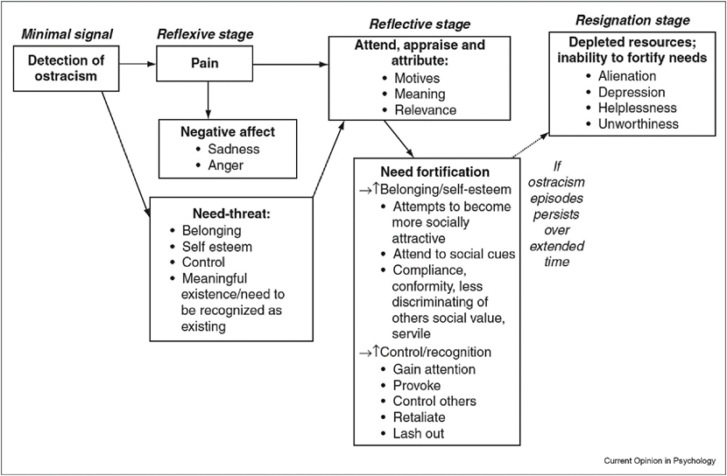

Fig. 1.The temporal need-threat model (Williams & Nida, 2022)

*In other words, ostracism, which includes feelings of rejection and exclusion, can have severe emotional and psychological effects on individuals. This painful experience threatens fundamental human needs, leading to negative responses that can manifest as either social withdrawal or aggressive behavior. Chronic ostracism can contribute to long-term depression and feelings of worthlessness, as it creates a cycle of isolation and emotional distress that can significantly impact mental health over time.*

### 1.5. Distinguishing Social Isolation from Social Death

Many socially isolated individuals are not crying out loud for help. They have simply withdrawn from the meaningful social interactions and relationships, leading to feelings of isolation. Research (Baumeister & Leary, 1995) shows that the need to belong is a fundamental human drive. When people feel excluded, it triggers the same areas of the brain associated with physical pain. Chronic social isolation (Cacioppo & Cacioppo, 2014) can lead to depression, anxiety, and even early mortality. By failing to recognise social isolation and death, we allow its devastating effects to spread silently.

Social death and social isolation are two different but related social phenomena that impact individuals' sense of belonging, identity, and well-being in distinct ways. Understanding the distinction between social death and social isolation is important in recognising the effects of exclusion and disconnection on individuals. Socialisation is a fundamental part of human existence, shaping our identity, building relationships, and contributing to well-being. When we lose our social connections, whether through isolation or more extreme forms of exclusion, the consequences can be severe. Kralova (2015) highlights that social death occurs when society stops recognising a person’s identity due to extreme neglect, marginalisation, or institutionalisation. This concept is particularly relevant in contexts such as elderly care, imprisonment, or stigma-related exclusion, where individuals are stripped of their social identity and recognition.

On the other hand, Cacioppo & Cacioppo (2018) explain that social isolation refers to the absence of social interactions and meaningful connections, which can lead to emotional distress, loneliness, and negative health outcomes. Unlike social death, isolation does not necessarily involve societal rejection, but it can still result in profound psychological and physiological consequences. Table 1 clarifies the main differences between social isolation and social death while contrasting them with introversion. This distinction highlights that while social isolation and social death are harmful states of disconnection or exclusion, introversion is simply a personality trait that does not inherently lead to negative social consequences. It is important to recognize that introverts may prefer solitude or selective socializing without experiencing feelings of loneliness or exclusion (Cain, 2012).

Table 1: Social Isolation vs Social Death vs Being Introverted (Cain, 2012; Cacioppo, et al, 2018; Kralova, 2015)

|  | **SOCIAL ISOLATION** | **SOCIAL DEATH** | **BEING INTROVERTED** |
| --- | --- | --- | --- |
| **Definition** | A situation where an individual lacks social connections or meaningful interactions. | A state in which a person is considered dead by society due to exclusion, neglect, or dehumanization. | A personality trait characterized by a preference for solitude or selective social engagement, without necessarily experiencing loneliness or exclusion. |
| **Causes** | Physical separation, lack of communication, voluntary or involuntary withdrawal from social networks. | Stigmatization, institutionalization, extreme marginalization, loss of social identity. | Natural temperament, personal preference, sensitivity to overstimulation, or a need for deeper, rather than frequent, interactions. |
| **Impact** | Feelings of loneliness, depression, and disconnection. | Loss of recognition, dignity, and identity in society. | May be misunderstood as social withdrawal but does not inherently cause distress or negative consequences. |
| **Examples** | A person living alone without strong social ties, individuals experiencing long-term quarantine. | Elderly individuals in nursing homes with no visitors, prisoners in solitary confinement, or people ostracized due to severe stigma. | Someone who enjoys spending time alone, prefers small gatherings over large crowds, or thrives in independent work environments. |
| **Reversibility** | Can be mitigated through reconnecting with social networks and seeking support. | Often difficult to reverse once a person is considered socially "dead." | Not something that needs "reversing"; introverts can adapt their social interactions based on personal comfort and need. |

Recognising the difference between these two damaging concepts is essential:

* Addressing social death involves restoring the individual's social identity and reintegrating them into societal interactions. This can be achieved by acknowledging their personhood, involving them in decision-making processes, and encouraging meaningful engagements (Borgstrom, 2017);
* In contrast, mitigating social isolation focuses on enhancing social connections through community programs, support groups, and technologies that facilitate communication, thereby improving mental and physical health outcomes (National Institute on Aging, 2023).

Being able to recognise signs of social isolation and death, we can prevent further deterioration of individuals' well-being. Indicators such as avoidance of social interactions, disengagement from daily activities, decline in health, and self-deprecating behaviour necessitate proactive measures to foster inclusion and support (Healthline, 2023).

One of the biggest challenges in tackling social isolation and death is that those affected rarely ask for help, even though it can take a toll on their mental, emotional, and physical well-being. The warning signs are often subtle and easily overlooked. These signs include:

* **Avoiding Social Interactions.** A person experiencing social isolation or death may withdraw from friends, family, or colleagues, declining invitations or avoiding conversations. This is particularly evident in elderly individuals in nursing homes, those facing homelessness, or people with stigmatised identities (Králová, 2015);
* **Showing Signs of Disengagement.** Declining participation in school, work, or community activities may indicate a deeper sense of detachment. Those who feel socially dead often lose motivation to engage because they feel invisible or unvalued by society (Králová, 2015);
* **Experiencing a Decline in Mental and Physical Health.** Research shows that social isolation increases the risk of depression, anxiety, cognitive decline, and cardiovascular diseases (Cacioppo & Cacioppo, 2018). Individuals suffering from social death may experience even greater health risks, as their exclusion from society often leads to neglect in healthcare and support services;
* **Displaying Self-Deprecating Language or Extreme Self-Sufficiency.** Some individuals adopt negative self-perceptions, believing they are unworthy of help or connection. Others may develop an excessive reliance on themselves to avoid the pain of rejection, reinforcing their exclusion from society (Králová, 2015; Cacioppo & Cacioppo, 2018).

At all levels of the workplace, there are clear signs that an employee may be socially isolated (Jenkins, n.d.):

1. **Sloppy Work**. A noticeable decline in work quality, increased errors, or missed deadlines may signal that an employee is struggling with loneliness;
2. **Lack of Learning and Development**. Disinterest in personal or professional growth opportunities can be a red flag for isolation;
3. **Change in Routine**. Alterations in work habits, such as arriving late or leaving early, may indicate disengagement;
4. **Stops Offering Input**. A previously active participant becoming silent during meetings or discussions can be a sign of withdrawal;
5. **Skips Social Gatherings**: Consistently avoiding team events or informal gatherings may suggest feelings of isolation;
6. **Negative Attitude**. Exhibiting pessimism or increased irritability can be associated with loneliness;
7. **Physical Symptoms**. Complaints about health issues, such as headaches or fatigue, can sometimes be linked to emotional well-being;
8. **Reduced Collaboration**. Avoiding teamwork or preferring to work alone may indicate a sense of isolation;
9. **Decreased Productivity**. A drop in output or efficiency can be a manifestation of underlying loneliness;
10. **Withdrawal from Decision-Making**. Reluctance to participate in decisions or share opinions can reflect feelings of disconnection.

Jenkins highlights that these signs may be subtle, and it's crucial for leaders and colleagues to be attentive and proactive in addressing them to foster a more connected and supportive work environment.

Social isolation and loneliness are critical public health issues recognized by the World Health Organisation, affecting individuals across all age groups, but certain populations are particularly at risk. Vulnerable groups include adolescents, who may face social isolation due to bullying and social media influences; older adults, who often experience isolation due to health decline and loss of loved ones; and those with chronic health conditions or sensory impairments, which can limit social interaction. Additionally, racial and ethnic minorities, LGBTQ+ individuals, men, homeless persons, and those with low socioeconomic status face heightened vulnerability to social isolation. Recognizing these at-risk groups and their challenges is vital for developing effective interventions to mitigate the negative impacts of social isolation on mental and physical health.  
 *In other words, many individuals facing social isolation go unnoticed as they withdraw from meaningful relationships, leading to feelings of loneliness. Research indicates that the need to belong is a fundamental human drive, and chronic social isolation can result in serious mental health issues. While social isolation involves a lack of connections, social death occurs when a person is no longer recognized by society due to extreme neglect or exclusion. Understanding these differences is crucial, as these phenomena can severely impact an individual's identity and well-being. Recognizing the signs of social isolation, such as avoidance of social interactions and disengagement, is essential for preventing further deterioration of mental and emotional health.*

## 2. Understanding Social Deprivation Pathway Development

This chapter explores how social isolation and deprivation can develop over time, affecting people’s mental health and behaviour. Different factors, such as lacking meaningful connections, feeling lonely for long periods, or experiencing rejection, can lead to social deprivation. For example, in schools, a student may feel left out by peers, receive little support from teachers, or face bullying. Employees might be overlooked for projects or excluded from team events in the workplace. Understanding these pathways is essential for educators and employers, as they can create more inclusive and supportive environments that enhance well-being, performance, and self-esteem through simple actions and policies.

### 2.1. The Importance of Attachment in Human Development

Humans have never been and will never be able to be fully independent and self-sufficient physically or emotionally. Humans exist exclusively through -and because of- their relationships with other people (e.g. an infant is almost completely dependent on the person who takes care of it). A multitude of thinkers and researchers (Pierre Bourdieu, Martin Buber, John Bowlby, Erik Erikson, George Herbert Mead, Jean Baker Miller) have highlighted that people develop mainly through their relationships with other people and not through their individual achievements.

A review of the literature suggests that children who have established a secure attachment with at least one adult have significant benefits in their adult lives (Howes et al., 1998). The scientific foundation of attachment theory has its roots in the work of the English psychiatrist John Bowlby (Bretherton, 2013), who worked with children with emotional difficulties, and was subsequently enriched by the research work of Mary Ainsworth (1978).

The concept of “attachment bond” is defined as an intense emotional relationship between the infant and the primary caregiver. It is a lasting emotional connection that produces the desire for continuous communication between the persons involved as well as discomfort during separation (the infant expresses discomfort when the reference person leaves) (Bowlby, 2008). The development of close emotional bonds with the caretaker allows infants to create a secure base from which to explore the world around them. On the other hand, it helps infants to gradually start understanding the needs and feelings of other people, distinguishing them from their own needs/feelings. The quality and type of the “attachment bond” has been recognized as a central element in personality development (Bowlby, 2008).

Thus, children begin to form their own psycho-spiritual image of themselves and others. This own perspective on the world is expanded as they grow and re-examined by the persons themselves, ultimately leading to a kind of internal mental organization (Ainsworth, 2015). For the smooth psychosocial development of the child, the role of the caregiver is particularly important. More specifically, the reference/attachment person has to carry out a demanding role, according to which -in addition to understanding and interpreting the child's emotions in an appropriate way- she/he must also recognize and regulate her/his own emotions equally appropriately.

Bessel van der Kolk (2005) notes that a “primary function” of parents is to help children learn to manage their tension. Repeated cycles of emotional upheaval, followed by relaxation after the caregiver’s calming intervention, provide the basis for developing a sense of trust and security. Over time, the child internalizes this co-regulation as an expectation of a calming response that provides the basis for learning self-regulation.

The results of various studies show that the attachment style that children develop with their caregivers has long-term consequences in their later lives as it is linked to the formation of their personality, the organization of their behaviour and the development of close/interpersonal relationships (Sheinbaum et al., 2015, Widom et al., 2018, Kafetsios, 2004).

By investigating the conditions where the (parental) environment is unable or systematically fails to respond to what Jeffrey Young (1990) describes as the **child's core emotional needs**, it is observed that -if this is the case- stable patterns develop, patterns consisting of memories, emotions and thoughts concerning the self and the relationship with others which are significantly dysfunctional.

More specifically, while most beliefs have a limited impact on our everyday lives, some affect our day-to-day functioning, including how we view ourselves and interact with others. These core beliefs, or schemas, are developed in early childhood through interactions with our primary caregiver(s). However, if we had an insecure relationship with our primary caregiver(s) or if the information we based our beliefs on was inaccurate, we may develop limiting or unhelpful beliefs. These types of negative beliefs are called **Early Maladaptive Schemas** (EMS- which were presented in detail in the previous section) (Attachment project, 2025).

**The origins of Early Maladaptive Schemas.** LeDoux’s (1998) research on the brain systems involved with fear conditioning and trauma suggests a model for the biological underpinnings of schemas. Early Maladaptive Schemas are the result of unmet core emotional needs. Aversive childhood experiences are their primary origin while other factors also play a role in their development, such as emotional temperament and cultural influences.

Based on Belsky's (2007) differential susceptibility hypothesis, Early Maladaptive Schemas are theorized to result from the interaction between a child's temperament and thwarted emotional needs in their early environment. In general, these schemas are typically the product of unfulfilled core emotional needs during childhood or adolescence, frequently associated with recurring toxic experiences rather than single incidents. A child’s temperament and personality traits play a role in their vulnerability to developing EMS, influencing how they perceive and respond to their environment and social contexts.

*In other words, humans are inherently dependent on their relationships, and secure attachments formed in childhood are crucial for healthy development. Research emphasizes that strong emotional bonds with caregivers provide a foundation for children to explore the world and understand their own and others' emotions. The nature of these attachments can significantly impact an individual's personality and social relationships later in life. Additionally, insecure or negative relationships can lead to dysfunctional beliefs, known as Early Maladaptive Schemas, which affect how individuals perceive themselves and interact with others throughout their lives.*

### 2.2 Exploring the Social Deprivation Pathways

As humans, we evolved to be part of a tribe for survival. Because of this, we all have an inherent need to belong. When we lack this sense of connection, we experience loneliness -our body’s way of signalling that we need social interaction to thrive.

Most maladaptive schemas develop during childhood and are activated in later life under specific circumstances. This is also the case with emotional deprivation schema, which originates from consistent neglect of emotional needs in childhood, leading to core beliefs that negatively impact one’s emotional health and behaviours, including difficulties with emotion expression, feelings of disconnection, and seeking emotionally unavailable partners. On the other hand, the social isolation schema originates from negative childhood experiences and family dynamics that instil a sense of not belonging, further influenced by adolescence and societal factors, which can lead to lifelong challenges in forming meaningful connections.

In the previous section, the sources of social isolation were extensively analysed (see social isolation). In the following section, the various ways in which social deprivation develops and their connection with the emergence of the form of social isolation schema will be decoded through the prism of emotional needs in childhood, personal circumstances & emotional temperament and other societal and cultural influences.

#### 

Fig. 2. Social Deprivation Pathway

**Emotional needs in childhood.** In general, the social isolation schema develops in childhood when a primary caregiver fails to attune to his/her child’s emotional needs. This can happen unintentionally if the caregiver misinterprets or overlooks the child's cues for attention and support. However, other factors may also contribute to the development of a social isolation schema. For example, a caregiver might treat a child differently from siblings or convey that acceptance is conditional on specific behaviours. Such patterns often arise from the caregiver’s own limitations -e.g. due to mental illness, past experiences, or unresolved maladaptive schemas- impairing their ability to provide the emotional support the child needs.

**Personal circumstances.** This schema may also develop due to a child's personal circumstances. Even if these circumstances were not overtly negative, they may have contributed to feelings of being different or set apart from others. A child might have experienced this due to factors such as disability, sexual orientation, intelligence, or physical appearance. Additionally, interactions outside home could have reinforced these feelings - especially if the child faced *bullying or exclusion*, for instance, due to exceptional intelligence or an unconventional appearance.

**Other societal and cultural factors.** This typically occurs when a child grows up in a socially isolated family or differs in some way from the mainstream – e.g. due to family background, religious beliefs, or financial status. Additionally, this schema may develop simply *from a lack of opportunities to form close connections*. For instance, if a child’s family moved frequently, they may have failed to build lasting friendships and develop a sense of belonging within a community.

*In other words, humans have a natural need to belong to a group for survival, and without this connection, we can feel lonely. Maladaptive schemas, like the emotional deprivation schema, often form in childhood due to neglect of emotional needs, leading to difficulties in expressing emotions and forming healthy relationships later in life. Similarly, the social isolation schema develops when a child's emotional needs aren't met by caregivers or when they feel different or excluded for various reasons. Factors such as personal circumstances, societal norms, and family dynamics can further contribute to these feelings, making it challenging for individuals to create meaningful connections as they grow older.*

### 2.3. Cycle of Social Isolation Schema

Describing the cycle of social isolation scheme,Psychology Blossom Center (2025) *s*uggest the three phases of development.

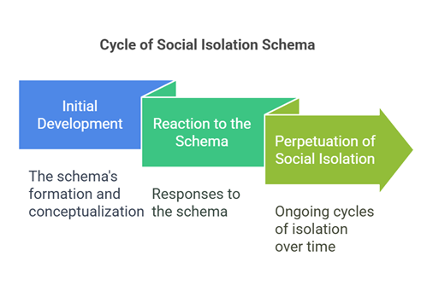

Fig. 3. Cycle of Social Isolation Schema

Understanding these elements can provide insight into the complex dynamics of social isolation and the factors that contribute to it.

**Phase one - Initial development**

This phase may be significantly determined by the following negative conditions:

**Discrimination:** Feeling different and discriminated against can stem from a family background that is noticeably distinct from others. This difference may arise from factors such as ethnicity, religion, or financial status, leading to feelings of alienation during formative years.

**Relocation:** Frequent relocations during childhood can hinder the development of deep friendships and connections. This instability may result in difficulties forming lasting relationships in adulthood, as the individual may struggle to trust or engage with others.

**Unfairness:** Experiencing differential treatment from parents compared to siblings can foster feelings of being the "black sheep" of the family. This perceived unfairness can lead to a sense of isolation and inadequacy.

**Trauma:** Experiences of bullying or abuse may significantly impact one's self-perception and social interactions. The trauma associated with these experiences can exacerbate feelings of being different and reinforce social isolation.

#### 

Fig. 4. Factors Contributing to Social Isolation

**Phase two - Reaction to the Schema**

As a response to the above-mentioned conditions, persons may be led to:

**Surrender:** Individuals may choose to follow others and suppress their own opinions to fit in. This surrendering of self can lead to a loss of identity and further isolation.

**Avoidance:** A common reaction is to avoid social events altogether, driven by the fear of being left out. This avoidance can create a cycle where the individual misses opportunities for connection.

**Overcompensation**: Some may react by becoming extremely extroverted, attending every social event, or engaging in substances as a coping mechanism. This overcompensation can mask underlying feelings of insecurity and isolation.

#### 

Fig. 5. How should one react to social pressure?

**Phase three - Perpetuation of Social isolation Schema**

This phase describes the procedure of a social isolation schema establishment.

A social isolation schema may be established if, for example, a person avoids attending a social event due to the fear of being left out. This absence may reinforce her/his belief of always being excluded, as others do not get the chance to know her/him better. Consequently, the individual continues to fear social situations and opts to steer clear of them, perpetuating the cycle of social isolation.

*In other words, the cycle of the social isolation schema consists of three key phases that explain how it develops and continues over time. Initially, negative experiences such as discrimination, frequent relocations, unfair treatment in the family, and trauma can create feelings of alienation and isolation. In response, individuals may surrender their identity, avoid social situations, or overcompensate by becoming overly sociable, which doesn't resolve their underlying feelings of insecurity. Ultimately, these actions can reinforce the belief that they will always be excluded, leading to a continuous cycle of social isolation.*

### 2.4. Life experiences: providing examples of social deprivation pathways

**The story of Joana, who wanted to belong**

#### 

*Joana was a 15-year-old high school student who desperately longed to feel like she belonged. When she first arrived in the host country at the age of 10, she was excited about the possibilities that school could offer. However, as time passed, Joana was constantly excluded from her peers. She tried to fit in, joining various groups like the choir and the theatre club, hoping to find a place to connect with others.*

*However, no matter how hard she tried, she was often left out of group activities. No one invited her to social gatherings or even acknowledged her presence in these spaces, leaving her feeling more isolated each day. Joana’s classmates sometimes mocked her accent and how she spoke, making her feel even more different. Coming from an immigrant background, she felt the sting of being treated as an outsider - someone who didn’t quite fit the Mold. Her teachers, busy with other responsibilities, overlooked her struggles. They overlooked the language barriers that made learning difficult for her and failed to recognise how hard Joana was working to meet her academic goals. This lack of support only deepened her sense of inadequacy, making her question whether she would ever find her place. At home, Joana’s parents, who also faced language barriers, could not offer the help she needed with her schoolwork and social interactions. They had few connections with the local community, and Joana often felt the weight of their struggles. Over time, Joana internalised these experiences, and her sense of social deprivation grew.*

*Her academic performance began to slip, and she withdrew further from her classmates, believing she was simply not meant to belong. The isolation she felt was no longer just external; it had become a part of her identity. As Joana’s belief that she didn’t fit in became entrenched, she found it harder to imagine a future where she felt accepted and valued. The pattern of social isolation she had developed began to shape her view of herself and her place in the world.*

**The Hidden Messages: Mark's Story**

#### 

*Mark has been a dedicated employee at a law firm for several years, but despite his qualifications and hard work, he often feels overlooked and excluded by his colleagues. He rarely receives invitations to social events or team-building activities, which deepens his sense of being an outsider. His manager, who frequently praises other employees, seldom acknowledges Mark’s contributions, leaving him feeling undervalued.*

*Mark is the only openly gay man on his team, which is predominantly composed of straight men. He frequently senses veiled homophobic jokes and subtle innuendos about his sexual orientation, further isolating him in the workplace. These negative experiences contribute to Mark's growing sense of disconnection, increasing his anxiety and reinforcing the belief that he doesn’t belong. On particularly stressful days, when the sense of “not fitting in” becomes overwhelming, Mark starts forgetting things and making mistakes at work.*

*This, in turn, leads to physical illness as his stress manifests in his body. Recently, the company’s HR manager was replaced by a woman keen on improving the team climate and implementing inclusivity protocols, as well as addressing harassment and burnout. As a result, Mark has been invited to several group sessions to address these issues. However, Mark desperately tries to avoid these meetings, often making excuses to stay away. His sense of isolation has grown so strong that he feels uncomfortable even in environments that are supposed to promote inclusivity.*

*Over time, the ongoing isolation has significantly impacted Mark’s job performance and mental health, leaving him unsure of how to navigate his place in the workplace.*

### 2.5. Managing Social Isolation in Workplaces

Relevant research increasingly shows that social isolation and deprivation can trigger cognitive shifts, emotional turmoil, and unhealthy coping mechanisms, resulting in increased stress, mental health issues, and risky behaviours. This cycle perpetuates further social exclusion, exacerbating psychological distress and negative behavioural responses over time (Delgado, 2023).

The occurrence of such phenomena in work settings has been linked to the connection between workplace experiences and schemas, largely due to the similarities between family and work environments. Researchers also suggest that managers resemble parents because of their authority, while coworkers function similarly to siblings within a family system (Bamber & ve McMahon, 2008). This parallelism suggests that challenges with parents and siblings at home may manifest in similar ways with managers and coworkers in the workplace.

Pascoe (2024) argues that “*these schemas shape how we view ourselves, others, and the world. While originally developed as coping mechanisms to protect us from emotional pain, they can become obstacles in adulthood, especially in the workplace. When unaddressed, these schemas can contribute to stress and burnout, but they also present valuable opportunities for personal growth and understanding”.* Based on this perspective each schema offers insight into our vulnerabilities and helps us identify unhelpful behavioural patterns. By recognizing these tendencies, we can enhance self-awareness, strengthen workplace relationships, and reduce the risk of burnout.

Effectively addressing maladaptive schemas requires **awareness, empathy, personal growth -but also social support**. Both employees and leaders can benefit from recognizing these patterns in the workplace and taking proactive steps to mitigate their effects. By fostering a culture of open communication, support, and continuous learning, organizations can empower individuals to break free from unhelpful patterns, creating a healthier and more productive work environment. For example, investing in professional development workshops that explore emotional intelligence, stress management, enhancing social and communication skills, understanding social dynamics can provide powerful tools to shift these barriers and cultivate a more resilient, confident workforce. To this end, many social interaction strategies might be particularly effective (Bay Area CBT Center, 2024).

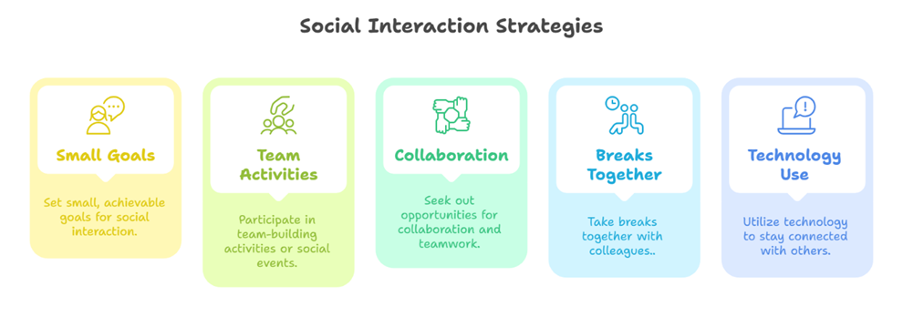

Fig. 6. Social Interaction Strategies

*In other words, social isolation in the workplace can lead to significant mental health challenges and unhealthy coping mechanisms, resulting in increased stress and further exclusion. The dynamics at work often mirror those in family environments, which means that unresolved issues with authority figures and peers can resurface in professional settings. Recognizing and addressing maladaptive schemas—patterns developed as coping mechanisms—can enhance self-awareness and improve workplace relationships, ultimately reducing burnout. By creating a supportive culture that encourages open communication and personal development, organizations can help individuals overcome these barriers and foster a healthier, more productive work environment.*

# 3. Identifying Knowledge, Skills, Competencies, and Experiences for Recognising Social Isolation

This chapter focuses on the essential knowledge, skills, and competencies needed to recognize individuals who may be experiencing social isolation. It aims to empower employers, adult educators, counsellors, adult learners, and employees with the understanding necessary to identify signs of social isolation and its underlying causes. By fostering empathy, active listening, and cultural sensitivity, alongside emotional intelligence and crisis intervention skills, we can create supportive environments for those feeling socially disconnected. The chapter offers practical steps and recommendations for training in these areas, highlighting the importance of building awareness and providing meaningful support to help individuals feel valued and included.

### 3.1. Knowledge: Understanding Beyond Social Isolation and Death

Addressing social isolation and social death requires more than empathy; it demands a **solid foundation of interdisciplinary knowledge** that enables individuals, educators, and SME owners to recognize, understand, and effectively combat these issues. Social isolation is not merely the absence of interaction but a complex and multifaceted phenomenon shaped by psychological, economic, cultural, and technological factors. To drive meaningful change, awareness must be reinforced with **targeted and continuously evolving knowledge.** This ensures that individuals are equipped with the necessary insights to foster inclusion, dismantle barriers, and create environments where genuine connection and participation can thrive.

To develop effective solutions, it is essential to understand social isolation and social death through an **interdisciplinary** lens incorporating sociology, psychology, and public health. Research highlights that social isolation stems from **interconnected factors** such as economic disparities, cultural norms, and digital changes, shaping exclusion at both individual and societal levels (Králová, 2015; Cacioppo & Cacioppo, 2018). Without addressing these root causes, interventions risk being superficial.

**Psychological and neuroscientific** studies show that social exclusion activates brain responses similar to physical pain, underscoring its biological impact (Eisenberger & Lieberman, 2004). Long-term isolation can lead to cognitive distortions, heightened stress, and increased risks of depression and anxiety (Hawkley & Cacioppo, 2010). Understanding these effects supports the development of evidence-based strategies for social engagement and mental health support.

**Recognizing common indicators** of social isolation involves identifying behavioral, emotional, and physical signs that appear across different settings. These may include social withdrawal, persistent feelings of loneliness or despair, declining physical health, and disengagement from daily activities. In institutional environments such as elder care facilities, schools, and workplaces, signs often emerge as increased absenteeism, reduced participation, and difficulty forming meaningful connections with others (Victor & Sullivan, 2019).

**A range of external factors** can significantly shape an individual's risk of experiencing social isolation. **Socioeconomic** conditions play a decisive role, as financial instability and employment precarity limit access to social opportunities (Cacioppo & Cacioppo, 2018). **Systemic discrimination** - whether based on race, gender, disability, or other identities - further amplifies the likelihood of exclusion, creating long-term barriers to social integration. **Cultural dynamics** also influence the experience of isolation; while collectivist cultures may obscure the visibility of isolation by maintaining surface-level interactions, highly individualistic societies often lack built-in support systems for those experiencing social disconnection (Triandis, 1995).

Beyond individual experiences, social isolation is also driven by **structural and systemic barriers**, including poverty, inadequate healthcare access, and policy failures. Discriminatory practices, inaccessible public services, and urban planning that neglects community-building all contribute to the increasing prevalence of social isolation in modern societies (Berkman et al., 2014). Equipping individuals with knowledge of these systemic determinants enables them to advocate for long-term, structural solutions rather than relying solely on short-term interpersonal interventions.

Institutions and organizations play a key role in shaping social inclusion through **workplace and** **institutional policies**. Policies that foster inclusion, diversity, and community engagement help prevent social isolation by incorporating early-warning systems, peer support, and accessible mental health services (Almeida et al., 2020). Effective monitoring and evaluation ensure ongoing improvement. Research shows that inclusive policies enhance employee retention, collaboration, and mental health while strengthening organizational culture and productivity (Paldon et al., 2024). Additionally, they help mitigate the impact of adverse life events, promoting stability and social connection (Aldossari et al., 2021).

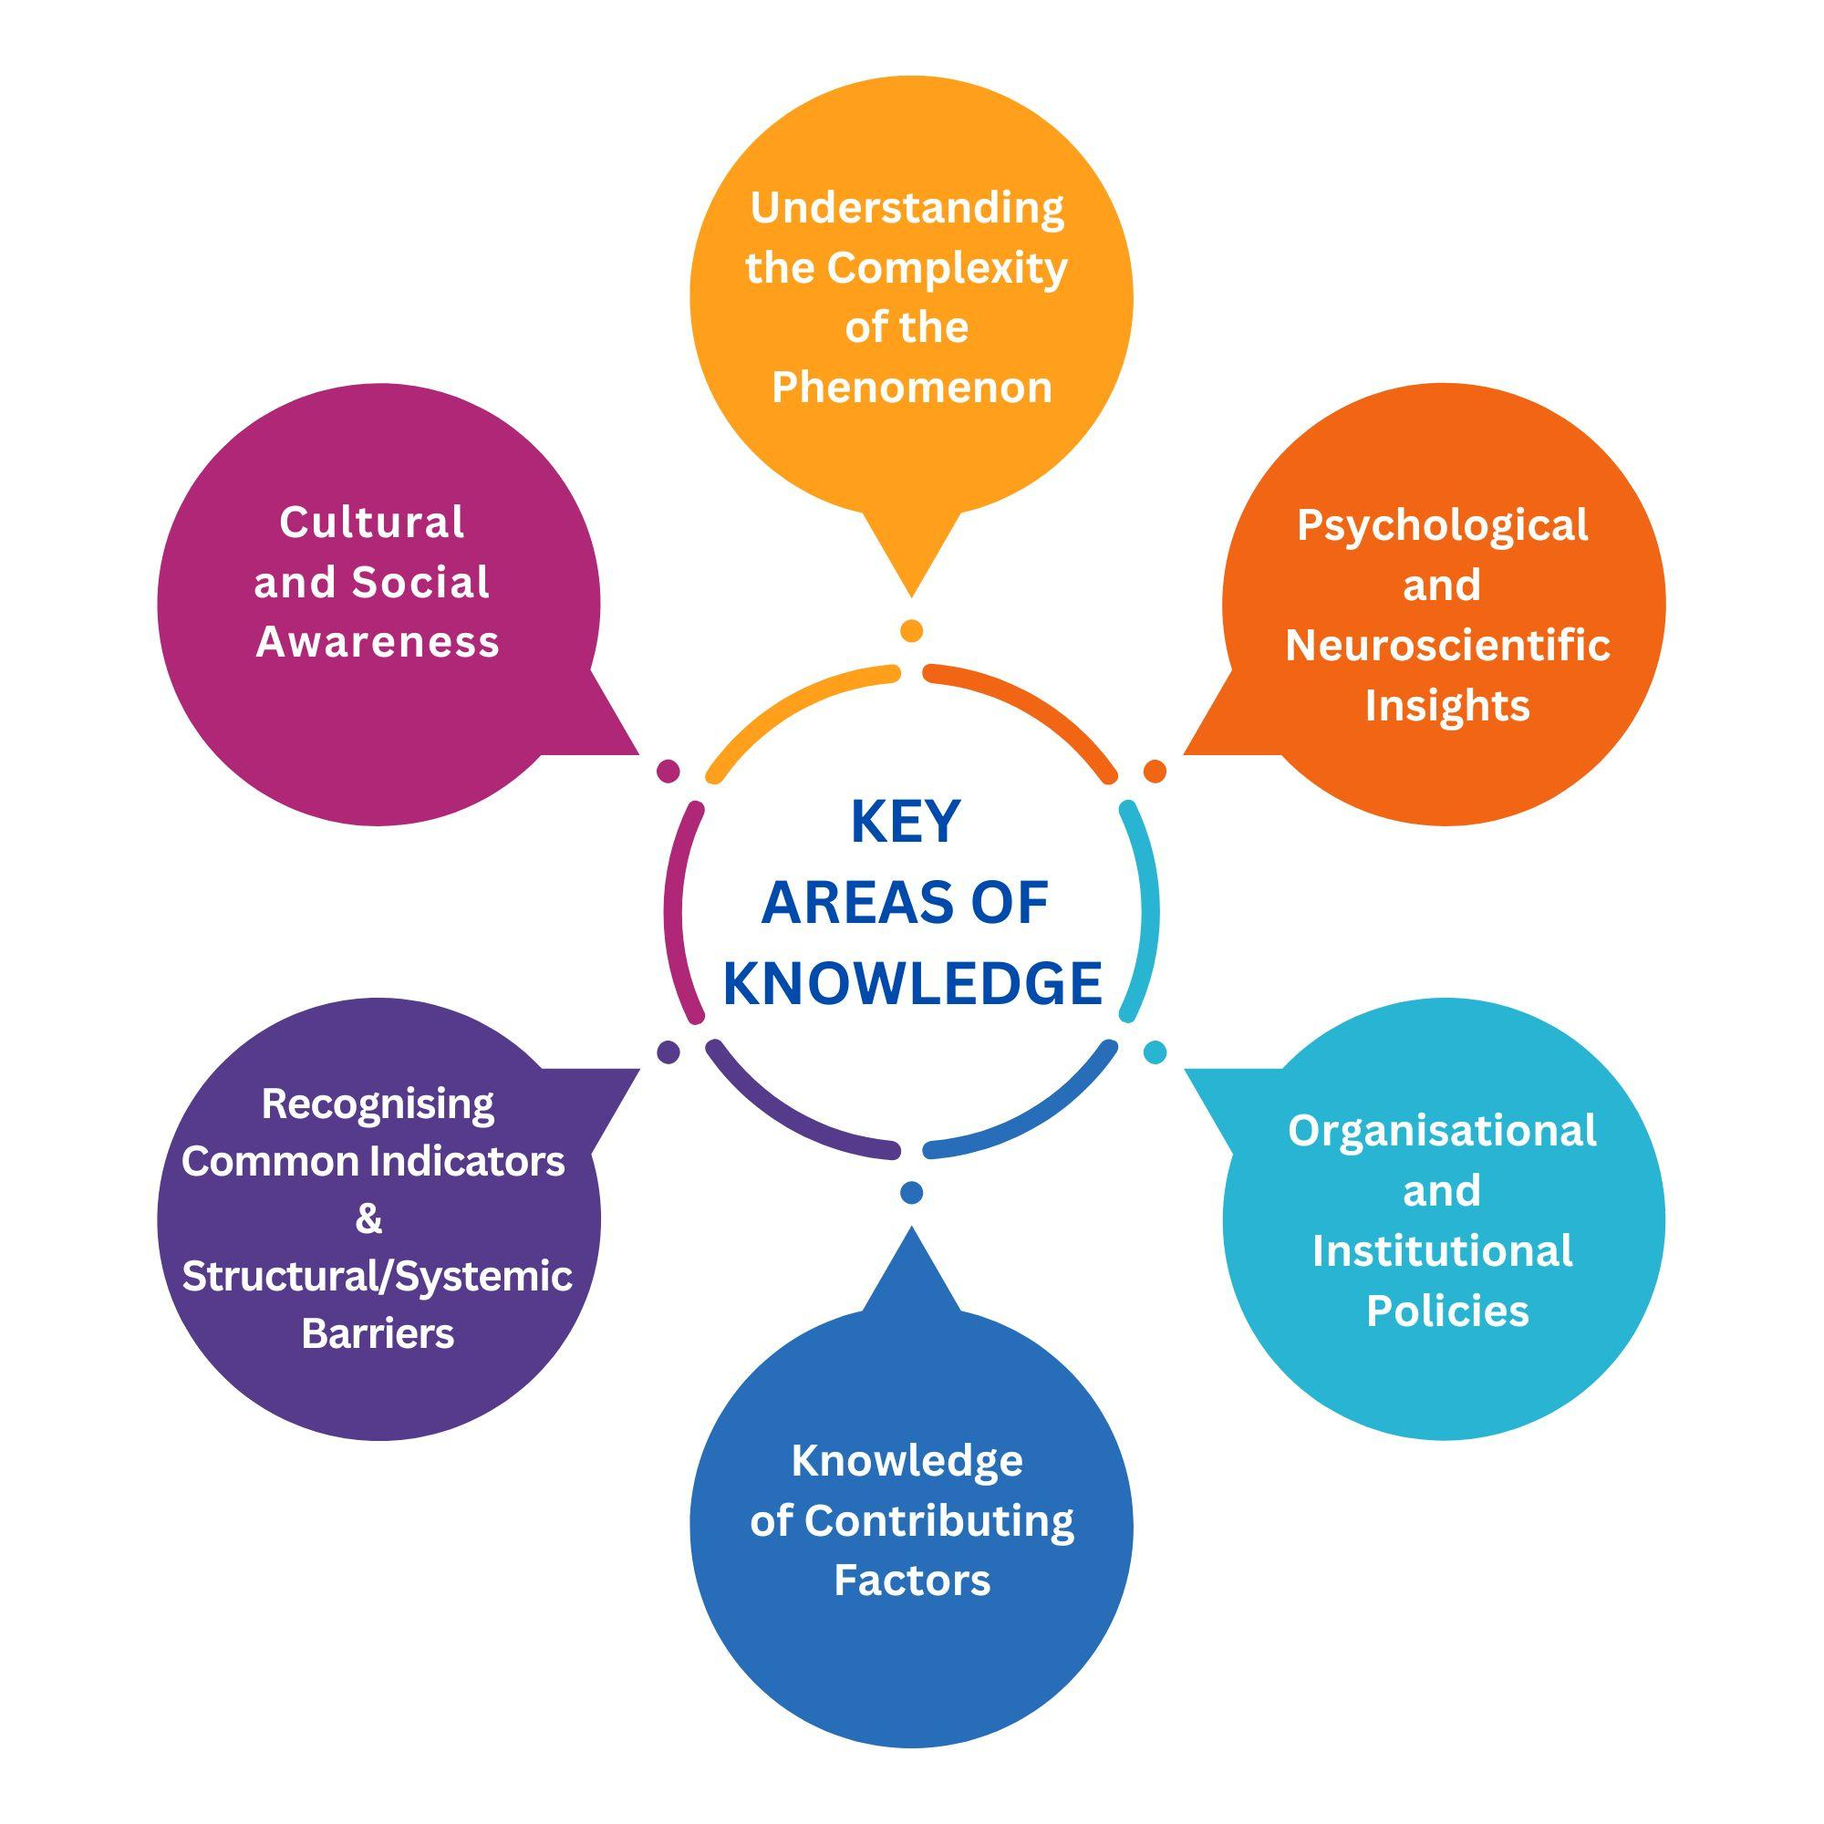

Fig 7. Key Areas of Knowledge

**In today’s fast-changing world, continuous learning is essential for acquiring new knowledge and effectively addressing social isolation.** Societal trends, technological advancements, and emerging research consistently reshape the ways in which isolation manifests, making lifelong learning a necessity. Staying informed ensures that interventions remain evidence-based, adaptable, and impactful. One of the most effective ways to expand knowledge is through formal education and training programs. Online and offline courses in social science, psychology, and public health offer valuable insights into human behavior and social dynamics. Universities and public institutions frequently provide specialized programs focusing on community development, mental health awareness, and social inclusion strategies.

Apart from formal education, **government reports, policy papers, and academic research** provide essential insights into social isolation. Organizations like the WHO and local health departments publish studies that guide policy and interventions. **Case studies, testimonials, and books** offer deeper perspectives on lived experiences, complementing quantitative data. Additionally, community research and local statistics from NGOs and government agencies help identify population-specific trends and risk factors.

**Engagement in professional networks and knowledge-sharing platforms** is another effective way to stay informed. Attending conferences, webinars, and networking events allows for direct engagement with experts in the field, fostering discussions on emerging trends and collaborative solutions. Participation in online communities and digital forums provides continuous access to evolving perspectives and best practices, ensuring that individuals working to combat social isolation remain at the forefront of knowledge in their respective fields.

By integrating these various sources of knowledge, individuals, educators, and SME owners can build a holistic and informed approach to tackling social isolation. This multidimensional understanding is key to identifying at-risk individuals, designing effective interventions, and ultimately fostering more inclusive and connected environments.

*In other words, addressing social isolation and social death requires a deep, multidisciplinary understanding that goes beyond empathy. It involves recognizing that social isolation is influenced by a myriad of psychological, economic, cultural, and technological factors. To effect meaningful change, individuals and organizations must continuously update their knowledge to foster environments that promote genuine connection and participation. Key areas of focus include understanding the complexity of social phenomena, identifying behavioral indicators of isolation, and being aware of systemic barriers that contribute to these challenges. Furthermore, cultural awareness and knowledge of effective policies can empower educators, employers, and policymakers to create inclusive environments that mitigate the impacts of isolation and enhance well-being across communities. Lifelong learning is essential to ensure that intervention strategies remain relevant and effective in a rapidly changing world.*

### 3.2. Skills: Applying Awareness in Real-Life Situations

Understanding social isolation and exclusion is just the first step; translating that awareness into practical action is essential. Recognizing, responding to, and mitigating social isolation in real-world scenarios requires a diverse set of skills. These skills form the **bridge between theory and practice**, preparing individuals to take meaningful steps toward building inclusive and supportive environments.

Addressing social isolation and social death effectively requires a combination of **cognitive, emotional, and behavioral skills**. These learned abilities enable individuals to recognize exclusion, respond compassionately, and implement solutions that help reintegrate affected individuals into society with dignity and support. By combining these three skill sets, individuals, educators, and SME owners can play an active role in **creating socially inclusive spaces**.

**Cognitive skills**, which focus on understanding and analyzing social isolation, play a crucial role in effective intervention. These skills allow individuals to identify early signs of exclusion and assess underlying factors rather than making assumptions. Research suggests that individuals who lack cognitive awareness of social exclusion are less likely to intervene effectively (Cacioppo & Cacioppo, 2018). **Critical thinking** is essential in analyzing both systemic and personal causes of isolation, while **perspective-taking** helps reduce bias by encouraging an understanding of diverse social and cultural experiences. Additionally, **problem-solving and decision-making** skills are necessary for developing and implementing strategies to prevent and address social isolation across different contexts.

Among cognitive skills, **awareness and recognition** are particularly vital. Without the ability to recognize subtle signs of exclusion, intervention becomes nearly impossible. In educational and workplace settings, an educator or employer who is attuned to signs such as withdrawal from group activities or a decline in participation can take early steps to foster a more inclusive and engaging environment.

**Emotional skills** are equally important in ensuring that responses to social isolation are not just rational but also compassionate and sustainable. Emotional intelligence enhances interpersonal connections, allowing individuals to provide support in ways that feel genuine and meaningful. Without emotional awareness, interventions may appear superficial or ineffective (Goleman, 2006). **Emotional regulation** is also critical, as it prevents personal biases or emotional fatigue from interfering with supportive efforts. In addition, **resilience** plays a role in dealing with setbacks and resistance, ensuring that efforts to build inclusivity remain consistent over time.

Among these emotional skills, **empathy and compassion** are particularly significant. Simply **listening without judgment** and acknowledging someone’s feelings can have a profound impact, as individuals who feel genuinely understood are more likely to engage socially and regain confidence (Goleman, 2006). In educational and professional settings, an educator or employer who consistently demonstrates empathy can create a safe and open space for individuals to express their struggles with social isolation, making intervention more effective and sustainable.

**Behavioral skills** focus on turning awareness and empathy into action. These skills enable individuals to actively promote social inclusion, foster connections, and advocate for change. Research has shown that social engagement and advocacy efforts significantly reduce feelings of isolation while improving overall well-being (Holt-Lunstad et al., 2015). **Effective communication** skills are essential for expressing concern and support in ways that build trust and encourage participation. **Active listening** fosters open dialogue, making people feel heard and valued.

Additionally, **advocacy and allyship** help in challenging exclusionary behaviors and policies, ensuring that organizations and communities actively promote inclusivity. **Conflict resolution skills** are important in addressing misunderstandings that may contribute to social isolation, while **community engagement** initiatives help build sustainable networks that prevent exclusion before it begins. Employers and educators who make a conscious effort to create inclusive environments contribute to networks where individuals feel connected, supported, and empowered.

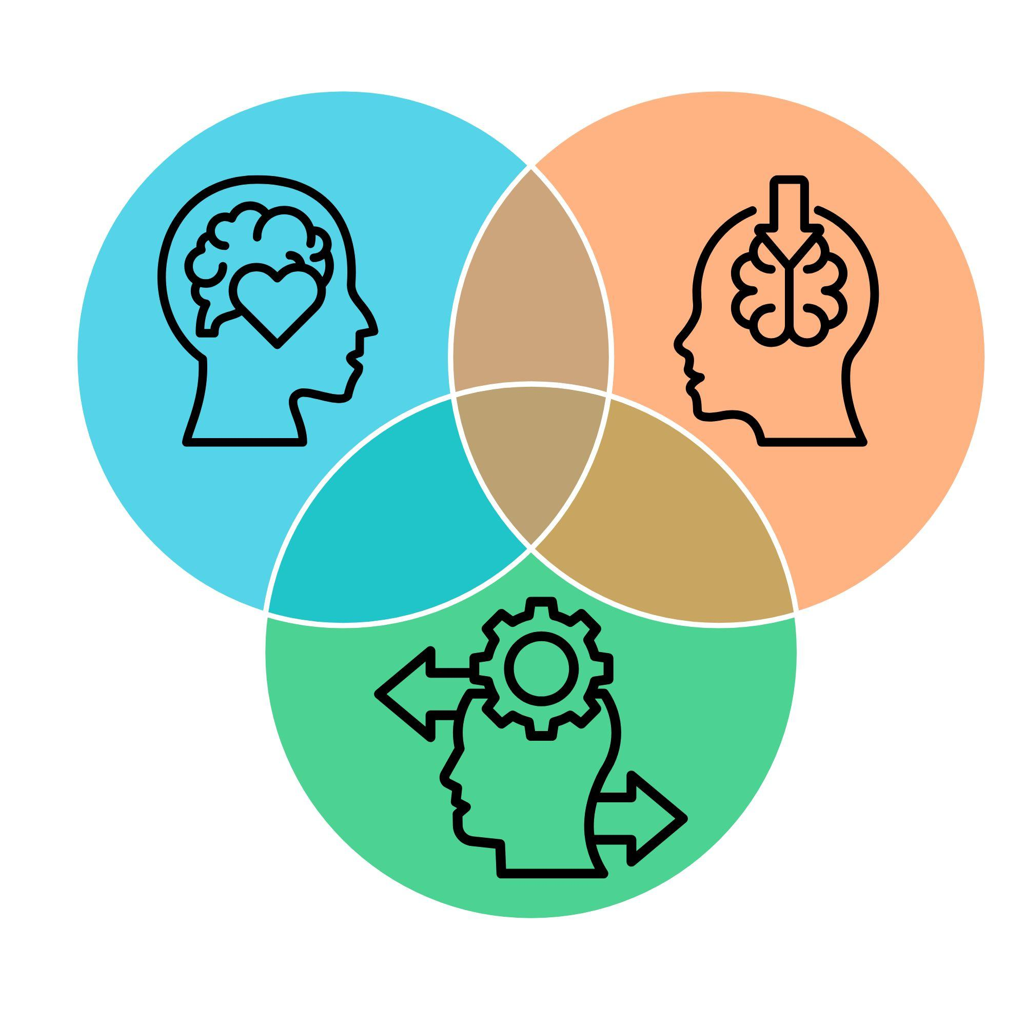

Fig. 8. Combination of Cognitive, Emotional and Behavioural Skills

**Refining these essential skills requires continuous learning and hands-on experience**. Training workshops and seminars provide interactive learning opportunities, focusing on active listening, crisis management, and effective communication. These sessions, often led by experts, integrate role-playing exercises and case studies, offering practical insights into addressing social isolation (Brown, 2020). Online courses and certifications are also valuable, as platforms like Coursera, edX, and FutureLearn offer self-paced programs on topics such as conflict resolution, trauma-informed communication, and leadership in social work (Goleman, 2006).

**Community involvement** plays a key role in developing these skills. Volunteering in outreach programs, shelters, or peer support groups provides real-world experience in recognizing and responding to social isolation, while **professional networking and peer learning** offer opportunities to exchange knowledge and gain mentorship from experienced practitioners.

**Simulated scenarios and role-playing** exercises allow individuals to practice intervention strategies in controlled environments. Crisis response drills and mediation simulations help build confidence and decision-making skills, preparing individuals to handle complex social challenges effectively. **Shadowing and observing experts**, such as community leaders, social workers, or mediators, provides direct exposure to real-life applications of essential skills, offering valuable insights into effective engagement strategies.

Developing skills for **social inclusion** also requires **self-reflection and ongoing assessment**. Keeping a journal, recording experiences, and seeking feedback from peers or mentors allows individuals to identify areas for growth and improvement. Reflection turns experience into structured learning, reinforcing long-term skill development (Kolb, 2014).

As digital communication plays an increasingly important role in outreach, **digital skill-building is becoming essential**. Learning online engagement techniques, such as social media advocacy and virtual support group facilitation, can enhance efforts to connect with socially isolated individuals.

*In other words, applying awareness of social isolation requires a combination of cognitive, emotional, and behavioral skills that bridge theory and practice. Cognitive skills, such as critical thinking and problem-solving, help individuals recognize early signs of exclusion and assess underlying causes. Emotional intelligence, including empathy and resilience, ensures responses are compassionate and sustainable. Behavioral skills turn awareness into action, fostering social inclusion through advocacy, communication, and active engagement. Continuous learning through training, community involvement, and self-reflection strengthens these abilities, while digital skills enhance outreach in an increasingly connected world. By actively cultivating these competencies, individuals can bridge the gap between awareness and meaningful action. The ability to recognize, respond to, and prevent social isolation depends on a well-rounded skill set that is continuously refined through education, experience, and reflection.*

### 3.3. Competences: The Ability to Take Effective Action

Competences represent the ability to **apply knowledge, skills, and attitudes effectively** in real-life situations to achieve meaningful outcomes. Unlike individual skills, competences integrate multiple abilities, enabling individuals to **a**dapt, solve problems, and navigate complex social environments (European Commission, 2006). Developing competences requires a structured and intentional approach, ensuring that interventions addressing social isolation and exclusion are both sustainable and impactful.

To effectively address social isolation, individuals must cultivate a range of **key competences** that empower them to navigate cultural, institutional, and interpersonal challenges. One of the most critical is **cultural and social awareness**, which involves recognizing how social isolation manifests differently across various cultural, economic, and societal contexts. Social isolation does not look the same everywhere—while collectivist cultures may obscure isolation by maintaining surface-level interactions, individualistic societies often equate loneliness with a lack of social connections (Triandis, 1995). Understanding these cultural nuances allows for the development of more effective and culturally sensitive interventions.

Equally important is the **ability to apply interdisciplinary knowledge**, integrating insights from sociology, psychology, neuroscience, public health, and policy studies to address the root causes and impacts of social isolation. Research highlights that social isolation is a multifaceted issue, influenced by factors such as psychological distress, economic instability, technological change, and structural inequalities (Cacioppo & Cacioppo, 2018).

The ability to remain **resilient and adaptable** is essential when working in emotionally demanding environments. Social isolation is often invisible, and progress may be slow or met with resistance (Hawkley & Cacioppo, 2010). Navigating these challenges requires the capacity to persist through setbacks, maintain emotional well-being, and adjust intervention strategies as needed.

Developing **ethical and inclusive leadership** ensures that social isolation is addressed not only at an individual level but also at institutional and systemic levels. Leaders who prioritize fairness, equity, and inclusivity play a crucial role in shaping workplace policies, educational environments, and community initiatives. Many barriers to social inclusion—such as discrimination, economic exclusion, and lack of accessibility—are deeply rooted in systemic inequalities (Berkman et al., 2014). Ethical leadership ensures that efforts to combat social isolation are strategic, sustainable, and aligned with human rights principles.

Another key competence is **policy and structural understanding**, which involves recognizing how policies, laws, and institutional structures exacerbate or alleviate social isolation. A lack of adequate mental health funding, affordable housing, and digital accessibility can significantly contribute to exclusion (Almeida et al., 2020). Individuals equipped with policy knowledge are better positioned to advocate for meaningful reforms, influencing decision-making at the community, organizational, and governmental levels.

**To strengthen these competences**, individuals must actively engage in diverse learning experiences, collaborate with others, and take on leadership roles that challenge problem-solving and decision-making abilities. One of the most effective ways to build competences is through **volunteering and community engagement**, which provides direct experience in applying knowledge in real-world settings. Studies indicate that hands-on experience in social projects enhances adaptability, problem-solving abilities, and deepens empathy—all essential for strong competences (Wilson, 2018).

**Shadowing, mentorship, and networking** are essential for competence development, offering practical insights into decision-making and fostering continuous learning. Observing experienced professionals in leadership, social work, or crisis management accelerates growth by integrating multiple skills into competent practice (Allen & Eby, 2011). Engaging with peers, experts, and community leaders through forums, conferences, and interdisciplinary discussions broadens perspectives, encourages innovation, and provides access to expert knowledge and best practices (Cross, Ernst, & Pasmore, 2013).

Beyond learning from others, competences are also strengthened through **advocacy and policy involvement**. Engaging in public consultations, policy discussions, or awareness campaigns develops strategic thinking and the ability to influence systemic change. Active participation in governance and policy-making empowers individuals to drive sustainable solutions, ensuring that social inclusion efforts extend beyond immediate interventions (American Counseling Association, 2018).

Taking on **leadership roles in initiatives and projects** provides opportunities to apply competences in real-time. Organizing community programs, awareness campaigns, or crisis response efforts fosters strategic planning, leadership, and decision-making abilities. These experiences cultivate accountability, adaptability, and the capacity to coordinate resources, ensuring that social inclusion efforts are both effective and sustainable (Project Management Institute, n.d.).

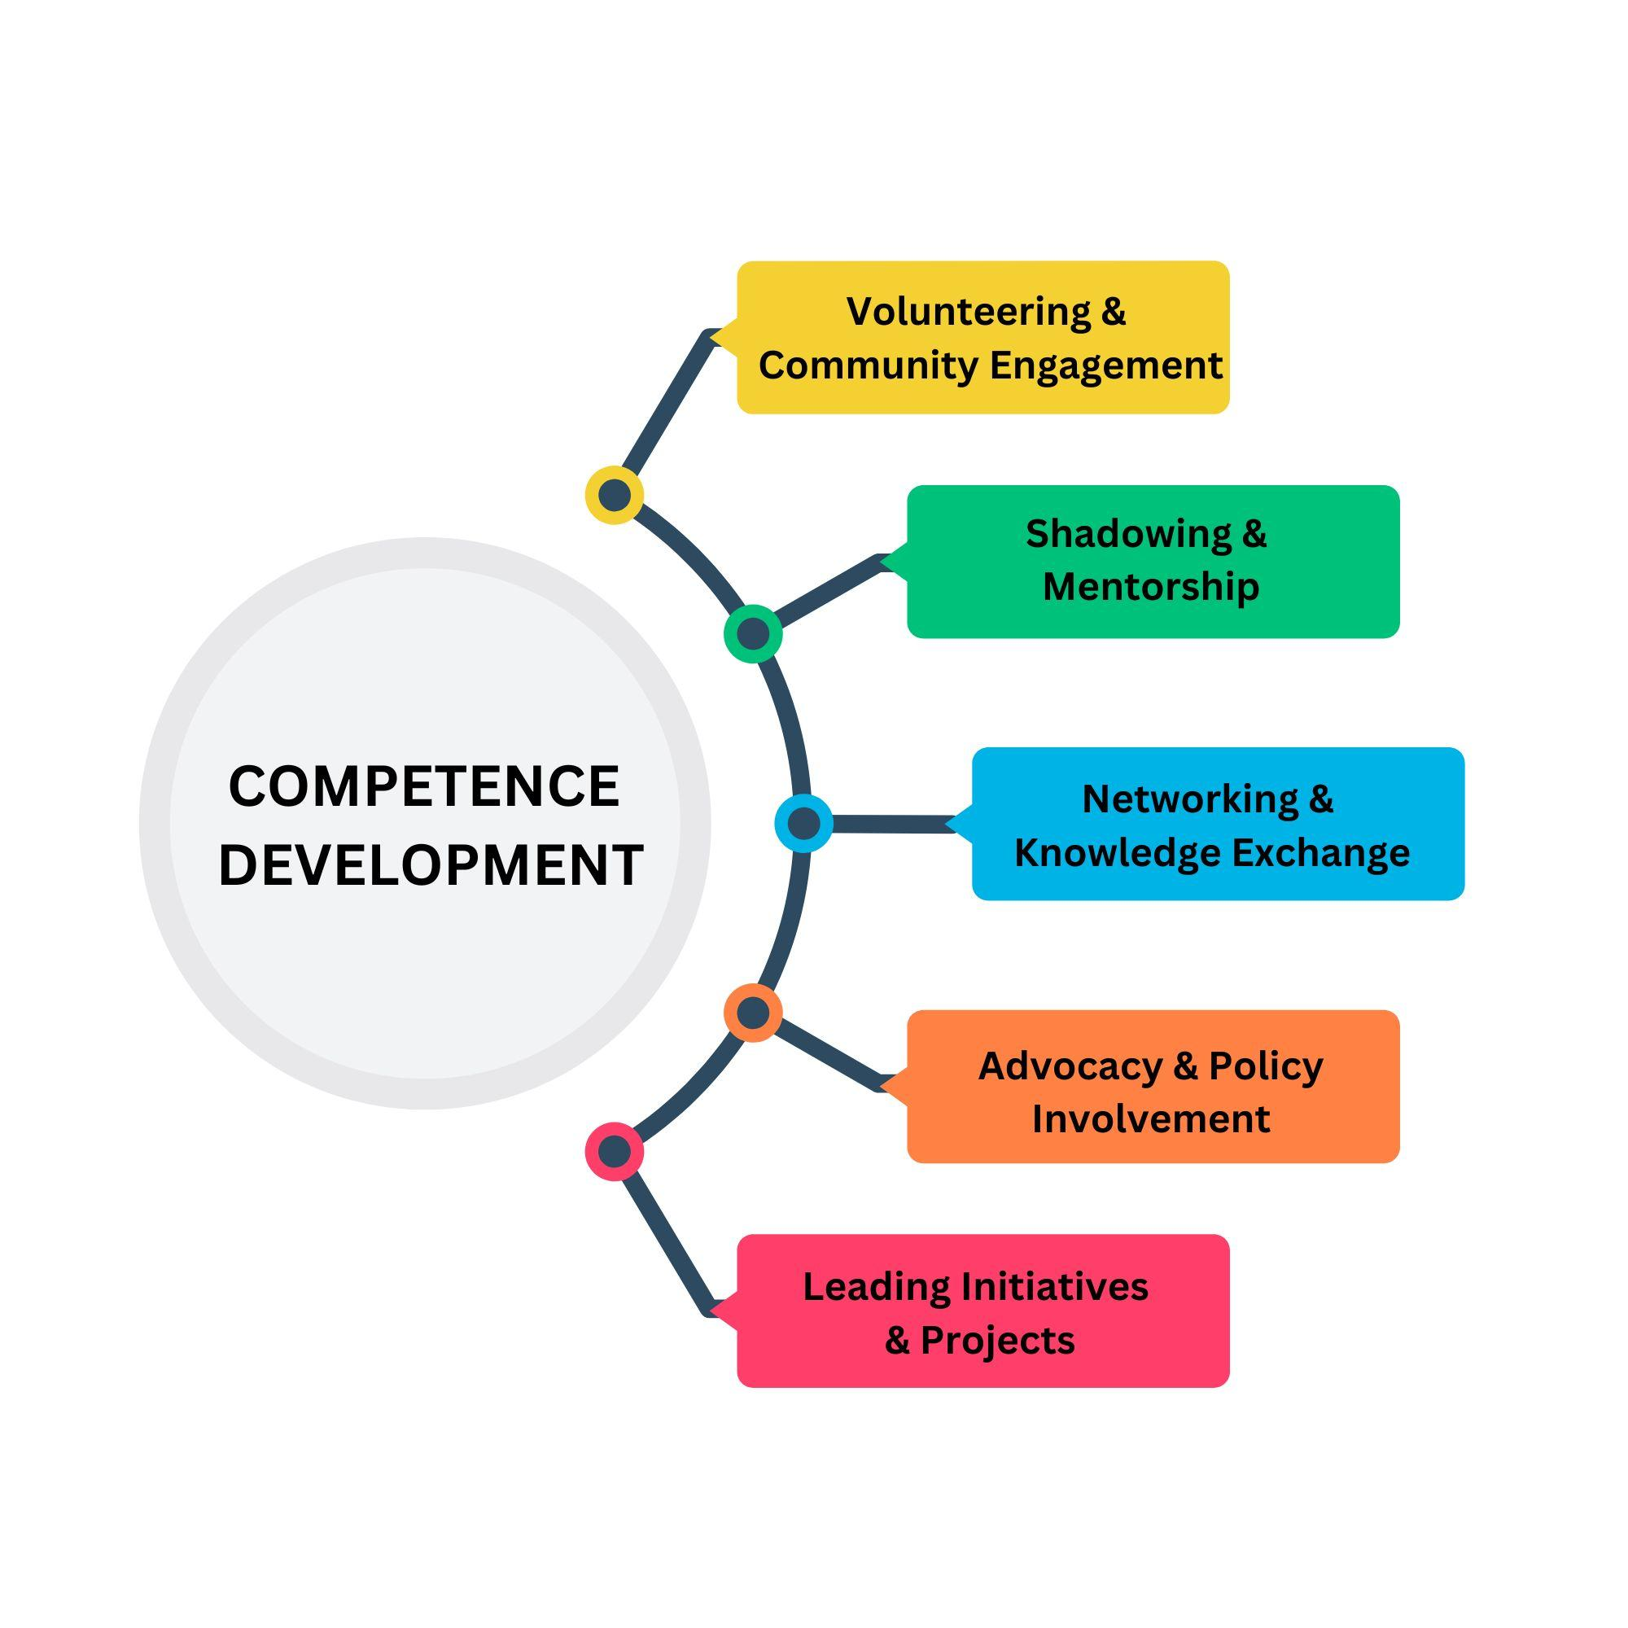

Fig. 9. Practical Approaches to Competence Development

When building competencies, it is essential to consider several key factors to ensure effectiveness and sustainability (American Psychological Association, 2019; National Alliance on Mental Illness, n.d.):

* **Avoiding overgeneralization** is crucial, as social isolation varies across individuals and cultures, requiring personalized approaches tailored to specific contexts.
* **Emotional investment** must also be balanced, as working with social isolation cases can be demanding; developing resilience and seeking peer support helps prevent burnout.
* **Addressing unconscious bias** through self-reflection and diversity training fosters inclusive and non-judgmental interactions.
* **Technology** should be leveraged mindfully, ensuring that digital tools support social inclusion ethically and remain accessible to all.
* Finally, **sustainability** is key—short-term interventions should evolve into long-term initiatives that create lasting social connections.

*In other words, competence-building is an ongoing process that requires active engagement, reflection, and adaptation. It extends beyond individual skills to encompass the ability to apply knowledge, navigate challenges, and take effective action in real-world situations. Addressing social isolation demands cultural awareness, interdisciplinary expertise, resilience, leadership, and policy understanding to drive meaningful, lasting change. Developing these competences involves continuous learning, collaboration with diverse professionals, and active participation in mentorship, advocacy, and community initiatives. By integrating knowledge, ethical leadership, and practical experience, educators, SME owners, and community leaders can create inclusive environments where strategic, impactful, and sustainable solutions ensure that no one is left behind.*

### 3.4. Experiences: Gaining and Creating Inclusive Environments

Experiences provide a **deeper understanding of social isolation** than theoretical knowledge alone. First-hand encounters, case studies, and real-world interactions enhance the ability to recognize and address exclusion, making inclusion efforts more effective. According to the WHO (n.d.), direct engagement with isolated individuals fosters empathy and strengthens the ability to identify subtle signs of exclusion. Educators and employers must not only participate in meaningful experiences to develop their competences but also create positive environments that prevent social isolation for learners and employees.

**Experiential Learning:** Developing competence in recognizing and addressing social isolation requires active engagement in diverse experiences. **Engaging with marginalized groups** provides direct insight into barriers to inclusion, building empathy and sharpening awareness of exclusionary patterns (WHO, n.d.). **Facilitating inclusive discussions** in educational and workplace settings encourages dialogue on diversity, equity, and belonging, normalizing inclusion efforts (Berkman, Kawachi, & Glymour, 2014). Designing and implementing **support programs**, such as peer mentorship initiatives or mental health resources, offers practical experience in reducing social isolation (Holt-Lunstad et al., 2015). **Managing conflicts and mediation** processes enhances the ability to address exclusionary behaviors and create safe, respectful environments (Cacioppo & Cacioppo, 2018).

Building **interdisciplinary collaboration** with psychologists, social workers, and HR specialists fosters a holistic approach to inclusion (Almeida & Monteiro, 2020). Actively participating in **community engagement and professional networks** deepens understanding of systemic challenges while providing access to best practices for fostering inclusion (Hawkley & Cacioppo, 2010). Exposure to **diverse learning and working styles**, including different cultural backgrounds and neurodivergent perspectives, enables educators and employers to implement more inclusive policies (Cacioppo & Cacioppo, 2018).

**Creating Positive Experiences:** While developing personal competence through experiential learning is essential, fostering inclusion also requires the intentional creation of positive experiences for learners and employees. By **designing environments that encourage connection, mutual support, and personal growth**, educators and employers can prevent social isolation and strengthen social bonds in both educational and workplace settings.

**For educators**, fostering inclusive learning environments can be achieved through experiential learning activities, such as role-playing, case studies, and guided discussions, which help students understand the emotional and psychological impacts of exclusion (Kolb, 2014). Establishing peer mentorship programs and collaborative projects encourages interpersonal connections, reducing the risk of student isolation (Allen & Eby, 2011). Creating safe and inclusive classrooms, where diversity is prioritized and open conversations are facilitated, ensures that students feel valued and supported (Gomes, Soares, & Gamboa, 2023).

**For employers**, building inclusive workplace experiences begins with implementing workplace wellness programs, including team-bonding activities, stress management initiatives, and mental health support services, which foster a sense of community (National Alliance on Mental Illness, n.d.). Encouraging open communication through regular feedback and check-ins promotes workplace belonging (Jenkins, 2022). Providing diversity and inclusion training raises awareness of unconscious biases and equips managers with strategies to combat exclusionary practices (Paldon, Motwani, & Sharma, 2024). Lastly, offering flexible work arrangements, such as remote work options and adaptable schedules, helps address diverse employee needs while reducing social isolation (Aldossari & Chaudhry, 2021).

By actively participating in meaningful experiences and intentionally shaping inclusive environments, educators and employers **strengthen social connections** and **reduce isolation**, fostering **engagement, collaboration, and long-term inclusivity**.

*In other words, real-life experiences are key to truly understanding and addressing social isolation. Engaging directly with individuals who face exclusion helps develop empathy and sharpens awareness of subtle signs of isolation. Simply learning about inclusion is not enough—educators and employers must actively participate in experiences that build their ability to recognize and respond to exclusion while also creating environments where meaningful connections can thrive. By encouraging open discussions, fostering mentorship, and implementing inclusive policies, they can prevent isolation before it happens. Whether in classrooms or workplaces, shaping positive experiences that promote belonging is just as important as gaining knowledge. When people feel valued and included, they are more likely to engage, collaborate, and contribute to a supportive community.*

### 3.5 Addressing Social Isolation Through Structured Interventions

Addressing social isolation requires a **multi-layered strategy** that integrates personal, community, institutional, and policy-driven interventions. Since isolation manifests differently across social and professional settings, a one-size-fits-all approach is ineffective. Instead, structured models help guide interventions at various levels, ensuring both preventative and restorative measures are applied effectively.

**Isolation Recovery Tree Model.** This model builds on Problem Tree Analysis (EAWAG, 2011), **distinguishing between root causes and visible consequences of isolation. It pr**ovides a structured approach where preventative strategies eliminate underlying causes, while restorative interventions support those already affected in reintegrating into society. **Root-level interventions** focus on systemic factors that contribute to isolation, such as economic instability, mental health stigma, and exclusionary social structures. Educational institutions and workplaces can reduce these risks by implementing inclusive policies, mentorship programs, and structured social activities that encourage participation and belonging. **Recovery-level interventions** address the immediate consequences of isolation, including social withdrawal and emotional distress. Actions such as structured peer support, digital engagement initiatives, and career development programs help individuals rebuild confidence and reconnect with their communities.

By addressing both the systemic causes and the personal consequences of isolation, this model ensures a balanced approach that is both **proactive**—preventing new cases of isolation—and **reactive**—helping individuals recover and reintegrate. This dual focus fosters long-term social inclusion and resilience (Cacioppo & Cacioppo, 2018).

**The Connection Cascade Stepwise Model.** This model structures interventions progressively to ensure sustainable impact. It outlines four levels of engagement: **(1) Awareness and Engagement** focuses on establishing low-pressure opportunities for social interaction, such as icebreaker activities, informal networking, and team-building exercises. **(2) Skill-Building and Inclusion** provides structured training on emotional intelligence, active listening, and collaborative problem-solving. **(3) Environmental and Institutional Change** embeds inclusive practices in workplace and educational policies, such as diversity and equity initiatives and mental health support structures. **(4) Long-Term Systemic Change** implements national or organizational policies that prioritize social well-being, such as mental health integration in curriculums and legal protections for workplace inclusivity.

Each step ensures that interventions move beyond short-term solutions, embedding social connection into institutional culture for lasting impact (Putnam, 2000).

Table 2: The Connection Cascade Model

| **Level of Depth** | **Focus** | **Real-Life Solutions in  Education and Work** | **Impact and Expected Outcomes** |
| --- | --- | --- | --- |
| **1. Surface Level: Awareness & Engagement** | Creating immediate, low-pressure social opportunities. | **Education:** Icebreaker activities, buddy systems for new students, student clubs.  **Workplace:** Informal team-building events, coffee breaks, interest-based chat groups. | Short-term social stimulation, reducing immediate feelings of isolation (Putnam, 2000). |
| **2. Structured Support: Skill-Building & Group Inclusion** | Providing structured training to enhance social confidence and communication. | **Education:** Peer mentoring programs, group projects with social integration focus, resilience workshops.  **Workplace:** Onboarding mentorships, active listening & team collaboration training, emotional intelligence coaching. | Strengthened social confidence, better adaptation to group settings (National Institute on Aging, 2023). |
| **3. Environmental and Institutional: Systemic Change in Key Spaces** | Creating policies and cultural shifts in organizations. | **Education:** Safe classroom environments, structured participation encouragement, inclusive curriculum design.  **Workplace:** Flexible work policies, DEI (Diversity, Equity, Inclusion) initiatives, mental health support programs. | Sustainable culture of inclusion in schools & workplaces (Putnam, 2000). |
| **4. Policy & Structural Change: Long-Term Systemic Solutions** | Implementing policies that ensure sustainable social well-being. | **Education:** Government-mandated social inclusion programs, mental health integration in curriculum.  **Workplace:** Legal protections for workplace mental health, national funding for social well-being programs. | Long-term institutional change preventing exclusion & isolation (Holt-Lunstad et al., 2015). |

**The Digital Inclusion Ladder Intervention Model.** With digital spaces shaping social interactions, this model ensures technology fosters connection rather than deepening isolation. It progresses through four stages: **(1) Digital Access and Literacy** ensures equitable participation by providing affordable internet, devices, and digital skills training. **(2) Digital Social Engagement** facilitates meaningful online interactions through virtual peer groups, professional networks, and community-building initiatives. **(3) Career and Educational Integration** uses digital platforms for skill-building, remote learning, and career development, empowering individuals professionally and socially. **(4) Systemic Digital Inclusion** establishes policies that regulate responsible digital engagement, ensuring long-term access and support for all individuals.

This model highlights the importance of ensuring that digital tools act as bridges to connection rather than barriers, particularly for marginalized or remote communities (Van Dijk, 2020).

**Successful implementation of these models** requires a structured and adaptable approach. The first step involves **assessing isolation risks** and identifying key factors contributing to social disconnection within institutions, workplaces, and communities. Conducting surveys, interviews, and observational studies can provide insights into the most pressing issues and ensure that interventions align with the specific needs of different populations (Holt-Lunstad et al., 2015).

Once risks are identified, structure your interventions by **applying relevant strategies and tools** based on multilevel models. Institutions and businesses should integrate the Isolation Recovery Tree Model to address both root causes and immediate consequences, ensuring a holistic intervention. The Connection Cascade Model should be implemented in a stepwise manner, beginning with awareness-building and progressing to institutional and policy-level changes. Finally, the Digital Inclusion Ladder should be utilized to bridge digital divides and enhance online social engagement (Cacioppo & Cacioppo, 2018).

**Monitoring and adaptation** are crucial for sustained success. Organizations should track engagement levels and well-being indicators through regular assessments and feedback loops. Adjustments should be made based on participation data, ensuring that interventions remain relevant and effective. Longitudinal studies and impact evaluations can further refine strategies and provide evidence-based recommendations (National Institute on Aging, 2023).

Ensuring long-term sustainability requires embedding social well-being principles into **institutional and policy frameworks**. Educational institutions should integrate inclusive curricula and mentorship programs, while workplaces should establish diversity, equity, and inclusion (DEI) initiatives alongside mental health support systems. At the policy level, national frameworks should guarantee equal access to mental health services and social support networks (OECD, 2021).

By strategically implementing these frameworks, educators, SME owners, and policymakers can drive meaningful change and foster stronger social connections in physical and digital spaces.

*In other words, addressing social isolation requires structured interventions at personal, community, institutional, and policy levels. Models like the Isolation Recovery Tree focus on both root causes and immediate consequences, while the Connection Cascade ensures progressive engagement, from awareness-building to systemic change. The Digital Inclusion Ladder emphasizes equitable digital access and meaningful online interactions. Effective implementation involves assessing risks, tailoring interventions to specific needs, and continuously monitoring outcomes. Educators, SME owners, and policymakers can foster lasting social connections and inclusion by embedding social well-being into institutional policies and national frameworks.*

## 4. Social Connectedness recommendations

Chapter 4 presents evidence-based recommendations to enhance social connectedness and reduce the risk of developing the Social Isolation Schema. This chapter provides individuals with clear, actionable advice that can be quickly followed without needing special skills or guidance. Each section challenges readers to make decisions and see the consequences of their actions, encouraging active engagement in their social well-being.

The scenarios in this chapter are designed to help readers practice the theoretical foundations learned in Chapters 1 through 3. Each subchapter presents four distinct scenarios, focusing on the perspectives of employers, employees, learners, and adult educators. By exploring these scenarios, readers will gain practical insights into how to foster connections, create supportive environments, and actively combat patterns of social isolation in various contexts.

### 4.1. Understanding the Social Isolation Schema

The scenarios presented here provide practical contexts in which individuals can navigate the challenges of social isolation. By considering perspectives from different roles—managers, colleagues, learners, and educators—readers will explore the complex interactions that contribute to feelings of exclusion. The scenarios will demonstrate both ineffective and effective strategies for fostering inclusion, revealing the consequences of various actions taken in response to social isolation.

By engaging with these scenarios, readers will not only strengthen their understanding of the Social Isolation Schema but also practice critical decision-making skills. The focus is on compassionate communication, proactive engagement, and creating supportive environments that encourage connection. Ultimately, this chapter aims to empower readers to apply the knowledge gained to real-world situations, promoting social connectedness and reducing the risk of social isolation within their communities.

### 4.2. Understanding Social Deprivation Pathway Development

The branching scenarios presented here provide practical, real-life contexts in which individuals can recognize and respond to the dynamics of social isolation. Drawing on insights from the Social Isolation Schema and grounded in the pathways of emotional deprivation and early maladaptive beliefs, these scenarios explore the perspectives of employees, managers, educators, and learners. Each scenario illustrates how personal history, emotional needs, and social environments intersect to shape behaviour and well-being.

Readers will encounter both helpful and unhelpful responses to isolation, highlighting the emotional and relational consequences of various choices. By actively engaging with these scenarios, individuals are encouraged to reflect on their own responses, practice compassionate communication, and consider inclusive strategies that foster a greater sense of belonging. The goal is to develop critical awareness and actionable skills that can be applied in educational, professional, and community settings—ultimately promoting emotional resilience, inclusion, and lasting social connection.

### 4.3. Identifying Knowledge, Skills, Competencies, and Experiences for Recognising Social Isolation

This section of branching scenarios focuses on the specific knowledge, skills, and interpersonal competencies needed to identify and respond to social isolation across diverse settings. Through these scenarios, featuring students, roommates, colleagues, and older adults, readers are guided to observe subtle behavioral cues, consider context-sensitive approaches, and practice appropriate interventions. Each scenario emphasizes key skills such as active listening, empathetic communication, trauma-informed awareness, and respectful boundary-setting.

By navigating different outcomes based on their choices, readers learn how trust is built through small, intentional actions and how missed opportunities can deepen isolation. These scenarios help learners internalize not only what to look for, such as silence, withdrawal, or disengagement, but also how to respond in ways that are inclusive, respectful, and effective. Ultimately, the aim is to equip individuals with practical tools to recognize isolation early, respond with care, and foster supportive environments that promote connection and psychological safety.

## CONCLUSIONS

The guide outlines the importance of community connections, emphasizing that it is essential for everyone in a community to feel they belong and are engaged. Feeling connected is vital for mental health and overall happiness. When individuals, especially in adult education and workplaces, feel included and appreciated, it creates an environment where everyone can support each other.

Civic engagement is highlighted as a powerful way to help individuals feel less isolated. By encouraging participation in community activities, organizations can empower people to share their ideas and skills, which helps build a stronger sense of community. Personal fulfillment and community growth are closely linked, demonstrating that when individuals contribute to the well-being of others, it enhances their own sense of purpose.

The guide stresses the need for awareness of emotional well-being in workplaces and educational settings. Attention to how others are feeling is essential since feelings of isolation can lead to mental health challenges. Developing emotional intelligence among individuals can significantly reduce feelings of loneliness. Programs focused on understanding and supporting one another can foster a culture of empathy and connection.

Additionally, the guide points out that it is vital for organizations to adapt their policies and practices to effectively reduce social isolation. This involves integrating strategies for inclusivity and support into the workplace culture. Providing training to help recognize signs of isolation can help create safer, more caring environments where everyone feels valued.

A comprehensive approach to addressing social isolation is necessary. Tailored solutions are needed that consider both broader issues, such as economic hardships that contribute to isolation, and personal support systems. By creating spaces that encourage social engagement, organizations can help individuals connect with others on a deeper level.

Finally, the guide emphasizes the commitment to ongoing learning as essential for community leaders, educators, and employers. Staying informed about social issues and mental health barriers allows for better understanding and a more effective response to the challenges of social isolation. By fostering a culture of continuous learning and openness, it becomes easier to support everyone in the community.

In conclusion, by promoting empathy, clear communication, and supportive practices, we can create environments that uplift everyone. This will help all individuals feel encouraged and connected in their personal lives and within their community. Taking these steps ensures that we can effectively combat social isolation and empower everyone to succeed together.

## REFERENCES

Ahmadpanah, M., Astinsadaf, S., Akhondi, A., Haghighi, M., Bahmani, D. S., Nazaribadie, M., Jahangard, L., Holsboer-Trachsler, E., & Brand, S. (2017). Early maladaptive schemas of emotional deprivation, social isolation, shame and abandonment are related to a history of suicide attempts among patients with major depressive disorders. *Comprehensive Psychiatry, 77*, 71–79.<https://doi.org/10.1016/j.comppsych.2017.05.008>

Ainsworth, M.D.S., Blehar, M.C., Waters, E., & Wall, S. (1979). Patterns of Attachment: A Psychological Study of the Strange Situation (1st ed.). *Psychology Press.*<https://doi.org/10.4324/9781315802428>

Aldossari, M., & Chaudhry, S. (2021). Work-life balance satisfaction: The role of religiosity and workplace support. *Community, Work & Family, 25*(1), 112–131.<https://doi.org/10.1080/13668803.2021.1987859>

Allen, T. D., & Eby, L. T. (Eds.). (2011). *The Blackwell handbook of mentoring: A multiple perspectives approach*. John Wiley & Sons.

Almeida, M., & Monteiro, A. (2020). Institutional strategies for social inclusion: Policies and best practices. *Journal of Social Policy Studies, 18*(3), 215-230.<https://doi.org/10.1080/13691457.2020.1765912>

American Counseling Association. (2018). *ACA advocacy competencies*. [Retrieved March 3, 2025, from https://www.counseling.org/docs/default-source/competencies/aca-advocacy-competencies-updated-may-2020.pdf](https://www.counseling.org/docs/default-source/competencies/aca-advocacy-competencies-updated-may-2020.pdf)

American Psychological Association. (2019). *The impact of social isolation: A growing problem for health and well-being*. Monitor on Psychology. [Retrieved March 3, 2025, from https://www.apa.org/monitor/2019/05/ce-corner-isolation](https://www.apa.org/monitor/2019/05/ce-corner-isolation)

Attachment Project. (2025). *Social isolation schema: Signs and causes.* Retrieved March 3, 2025, from<https://www.attachmentproject.com/early-maladaptive-schemas/social-isolation/>

Bamber, M., & McMahon, R. (2008). Danger—Early maladaptive schemas at work! The role of early maladaptive schemas in career choice and the development of occupational stress in health workers. *Clinical Psychology & Psychotherapy, 15*(2), 96–112.<https://doi.org/10.1002/cpp.564>

Bär, A., Bär, H. E., Rijkeboer, M. M., Lobbestael, J. (2023). Early Maladaptive Schemas and Schema Modes in clinical disorders: A systematic review. *Psychology and Psychotherapy: Theory, Research and Practice*, 96, 716–747.<https://doi.org/10.1111/papt.12465>

Bauman, Z. (1992). *Mortality, immortality, and other life strategies*. Stanford University Press.

Baumeister, R. F., & Leary, M. R. (1995). The need to belong: Desire for interpersonal attachments as a fundamental human motivation. *Psychological Bulletin, 117*(3), 497-529.<https://doi.org/10.1037/0033-2909.117.3.497>

Bay Area Cognitive Behavioural Therapy Center Schema. (2024). *Understanding the social alienation and isolation schema*. Retrieved March 3, 2025, from <https://bayareacbtcenter.com/understanding-the-social-alienation-and-isolation-schema/>

Beck, A. T. (1967). *Depression: Causes and treatment*. University of Pennsylvania Press.

Belsky, J., Bakermans-Kranenburg, M. J., & Van IJzendoorn, M. H. (2007). For better and for worse: Differential susceptibility to environmental influences. Current directions in psychological science, 16(6), 300-304.<https://doi.org/10.1111/j.1467-8721.2007.00525.x>

Berkman, L. F., Kawachi, I., & Glymour, M. M. (2014). *Social epidemiology* (2nd ed.). Oxford University Press.

Borgstrom, E. (2017). Social death. *QJM: An International Journal of Medicine, 110*(1), 5–7.<https://doi.org/10.1093/qjmed/hcw185>

Bowlby, J. (2008). *A secure base: Parent-child attachment and healthy human development*. Basic Books.

Bretherton, I. (2013). *The origins of attachment theory: John Bowlby and Mary Ainsworth*. In Attachment theory, 45–84. Routledge.

Brown, B. (2020). *Dare to lead: Brave work. Tough conversations. Whole hearts.* Random House.

Cacioppo, J. T., & Cacioppo, S. (2014). Social relationships and health: The toxic effects of perceived social isolation. *Social and Personality Psychology Compass, 8*(2), 58-72.<https://doi.org/10.1111/spc3.12087>

Cacioppo, J. T., & Cacioppo, S. (2018). *Loneliness: Human nature and the need for social connection.* W.W. Norton & Company.

Cain, S. (2012). *Quiet: The power of introverts in a world that can't stop talking.* Crown Publishing.

Chen, Z., Poon, KT., Jiang, T.,Teng, F. (2025). Psychosocial and behavioural consequences of ostracism across contexts. *Nature Reviews Psychology*.<https://doi-org.resursi.rtu.lv/10.1038/s44159-024-00393-y>

Cross, R., Ernst, C., & Pasmore, B. (2013). A bridge too far? How boundary-spanning networks drive organizational change and effectiveness. *Organizational Dynamics, 42*(2), 81-91. <https://doi.org/10.1016/j.orgdyn.2013.03.001>

Delgado, M. R., Fareri, D. S., & Chang, L. J. (2023). Characterizing the mechanisms of social connection. Neuron, 111(24), 3911–3925.<https://doi.org/10.1016/j.neuron.2023.09.012>

EAWAG. (2011). *Problem tree analysis: Identifying causes, effects, and possible solutions.* Swiss Federal Institute of Aquatic Science and Technology. [Retrieved March 3, 2025, from https://www.eawag.ch/fileadmin/Domain:1/Abteilungen/sandec/schwerpunkte/sesp/CLUES/Toolbox/t8/D8_1_Problem_Tree_Analysis.pdf](https://www.eawag.ch/fileadmin/Domain:1/Abteilungen/sandec/schwerpunkte/sesp/CLUES/Toolbox/t8/D8_1_Problem_Tree_Analysis.pdf)

Edwards, A. A., Steacy, L. M., Siegelman, N., Rigobon, V. M., Kearns, D. M., Rueckl, J. G., & Compton, D. L. (2022). Unpacking the unique relationship between set for variability and word reading development: Examining word- and child-level predictors of performance. Journal of Educational Psychology, 114(6), 1242–1256.<https://doi.org/10.1037/edu0000696>

Eisenberger, N. I., & Lieberman, M. D. (2004). Why it hurts to be left out: The neurocognitive overlap between physical pain and social pain. *Trends in Cognitive Sciences, 8*(7), 294-300. <https://doi.org/10.1016/j.tics.2004.05.010>

Eisenberger, N. I., Lieberman, M. D., & Williams, K. D. (2003). Does rejection hurt? An fMRI study of social exclusion. Science, 302 (5643), 290–292.<https://doi.org/10.1126/science.1089134>

European Commission. (2006). *Key competences for lifelong learning – A European reference framework.* Office for Official Publications of the European Communities. Retrieved March 1, 2025, from <https://op.europa.eu/en/publication-detail/-/publication/297a33c8-a1f3-11e9-9d01-01aa75ed71a1/language-en>

Galea, S., Tracy, M., Hoggatt, K. J., DiMaggio, C., & Karpati, A. (2011). Estimated deaths attributable to social factors in the U.S. *American Journal of Public Health, 101*(8), 1456–1465.<https://doi.org/10.2105/AJPH.2010.300086>

Goleman, D. (2006). *Emotional Intelligence: Why It Can Matter More Than IQ*. New York: Bantam Books.

Gomes, C., Soares, A. D., & Gamboa, V. (2023). Lifelong learning in the educational setting: A systematic literature review. The Asia-Pacific Education Researcher, 33(2), 407–417. <https://doi.org/10.1007/s40299-023-00736-9>

Griffiths, M. D. (2014). Early maladaptive schemas in development of addictive disorders as parts of the complex addiction jigsaw. *International Journal of High Risk Behaviors and Addiction, 3*(3), e16746.<https://doi.org/10.5812/ijhrba.16746>

Hawkley, L. C., & Cacioppo, J. T. (2010). Loneliness matters: A theoretical and empirical review of consequences and mechanisms. *Annals of Behavioral Medicine, 40*(2), 218-227. <https://doi.org/10.1007/s12160-010-9210-8>

Holt-Lunstad, J., Smith, T. B., Baker, M., Harris, T., & Stephenson, D. (2015). Loneliness and social isolation as risk factors for mortality: A meta-analytic review. Perspectives on Psychological Science, 10(2), 227–237.<https://doi.org/10.1177/1745691614568352>

Howes, C., & Ritchie, S. (1998). Changes in Child–Teacher Relationships in a Therapeutic Preschool Program. Early Education and Development, 9(4), 411–422.<https://doi.org/10.1207/s15566935eed0904_6>

<https://doi.org/10.3928/00485713-20050501-06>

Kafetsios, K. (2004). Attachment and emotional intelligence abilities across the life course. *Personality and individual Differences*, 37(1), 129-145.<https://doi.org/10.1016/j.paid.2003.08.006>

Kip, A., Erle, M. T., Sleegers, W. A. W., & van Beest, I. (2025). Choice availability and incentive structure determine how people cope with ostracism. Journal of Experimental Social Psychology, 117, 104707.<https://doi.org/10.1016/j.jesp.2024.104707>

Kolb, D. A. (2014). *Experiential learning: Experience as the source of learning and development* (2nd ed.). Pearson Education.

Králová, J. (2015). What is social death? *Contemporary Social Science, 10*(3), 235-248.<https://doi.org/10.1080/21582041.2015.1114407>

Kwak, K.H., Lee, S.J. (2015). A comparative study of early maladaptive schemas in obsessive-compulsive disorder and panic disorder, *Psychiatry Research*, 230, pp. 757-762. DOI:<https://doi.org/10.1016/j.psychres.2015.11.015>

National Academies of Sciences, Engineering, and Medicine. (2020). Social isolation and loneliness in older adults: Opportunities for the health care system. National Academies Press.<https://doi.org/10.17226/25663>

Paldon, T., Motwani, B., & Sharma, N. (2024). Impact of workplace inclusivity on employee morale and performance. *International Journal of Scientific Research in Engineering and Management, 8*(3), 1–5.<https://doi.org/10.55041/IJSREM29839>

Pascoe, M. (2024, October 31). How early maladaptive schemas impact the workplace (and what to do about it). Medium.

<https://medium.com/@thrivingminds/how-early-maladaptive-schemas-impact-the-workplace-and-what-to-do-about-it-2c6335bbdcec>

Platts, H., Mason, O., & Tyson, M. (2005). Early maladaptive schemas and adult attachment in a UK clinical population. Psychology and Psychotherapy: Theory, Research and Practice, 78(4), 549–564. [https://doi.org/10.1348/147608305X41371​](https://doi.org/10.1348/147608305X41371%E2%80%8B)

Psychology Blossom. (2025). Social isolation schema. Psychology Blossom. Retrieved March 3, 2025, from<https://psychologyblossom.com/resources/what-is-social-isolation-schema/>

Rudert, C.S., Janke, S., Greifeneder, R. (2021) Ostracism breeds depression: Longitudinal associations between ostracism and depression over a three-year-period, *Journal of Affective Disorders Reports*, 4, 100118, ISSN 2666-9153,<https://doi.org/10.1016/j.jadr.2021.100118>.

Rudert, S. C., & Greifeneder, R. (2016). When it’s okay that I don’t play: Social norms and the situated construal of social exclusion. *Personality and Social Psychology Bulletin*, 42(7), 955-969, https://doi10.1177/0146167216649606

Sfeir, M., Postigo, Á., Fekih-Romdhane, F., González-Nuevo, C., Malaeb,D., Hallit, S., Obeid, S. (2025). Psychometric properties of the Arabic version of the Young Schema Questionnaire Short Form-Version 3 (YSQ-S3). *Scientific Reports*,15, 406.<https://doi-org.resursi.rtu.lv/10.1038/s41598-024-83089-w>

Sheinbaum, T., Kwapil, T. R., Ballespí, S., Mitjavila, M., Chun, C. A., Silvia, P. J., & Barrantes-Vidal, N. (2015). Attachment style predicts affect, cognitive appraisals, and social functioning in daily life. Frontiers in Psychology, 6, 296.[https://doi.org/10.3389/fpsyg.2015.00296​](https://doi.org/10.3389/fpsyg.2015.00296%E2%80%8B)

Steele, C., Kidd, D. C., & Castano, E. (2014). On Social Death: Ostracism and the Accessibility of Death Thoughts. *Death Studies*, 39(1), 19–23.<https://doi.org/10.1080/07481187.2013.844746>

Triandis, H. C. (1995). Individualism & collectivism. *Personality,* 69 (6), 907-924.<https://doi.org/10.1111/1467-6494.696169>

Van der Kolk, B. A. (2005). Developmental Trauma Disorder: Toward a Rational Diagnosis for Children with Complex Trauma Histories. Psychiatric Annals, 35, 401-408.

Victor, C. R., & Sullivan, M. P. (2019). Social isolation and loneliness in old age: Review and model refinement. *Aging & Mental Health, 23* (2), 161-167.<https://doi.org/10.1080/13607863.2017.1410270>

Widom, C. S., Czaja, S. J., Kozakowski, S. S., & Chauhan, P. (2018). Does adult attachment style mediate the relationship between childhood maltreatment and mental and physical health outcomes? Child Abuse and Neglect, 76, 76:533-545. https://doi: 10.1016/j.chiabu.2017.05.002.

Williams, K. D. (2007). Ostracism. *Annual Review of Psychology*, 58, 425–452. https://doi. org/10.1146/annurev.psych.58.110405.085641

Williams, K. D. (2009). Ostracism: A temporal need‐threat model. *Advances in experimental social psychology*, 41, 275-314. Elsevier Academic Press.<https://doi.org/10.1016/S0065-2601(08)00406-1>

Williams, K. D., Nida, S.A. (2022). Ostracism and social exclusion: Implications for separation, social isolation, and loss, *Current Opinion in Psychology*, 47, 101353, ISSN 2352-250X, <https://doi.org/10.1016/j.copsyc.2022.101353>.

World Health Organization. (n.d.). *Social isolation and loneliness.* Retrieved March 3, 2025, from <https://www.who.int/teams/social-determinants-of-health/demographic-change-and-healthy-ageing/social-isolation-and-loneliness>

Young, E. J., Klosko, S. J., Marjorie, E. (2003). *Schema Therapy: A Practitioner's Guide, Weishaar Copyright*, Guilford Publications.

Young, J. E. (1999). *Cognitive Therapy for Personality Disorders: A Schema-Focused Approach*, Professional Resource Press/Professional Resource Exchange.

Young, J. E., Klosko, J. S. & Weishaar, M. E. (2006). *Schema Therapy: A Practitioner’s Guide*, The Guilford Press.